1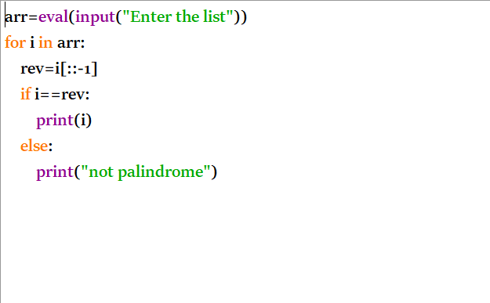
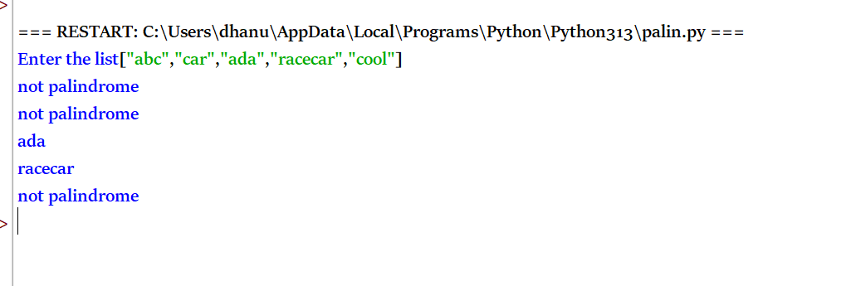
TIME COMPLEXITY: O(n × m)
SPACE COMPLEXITY: O(1)
2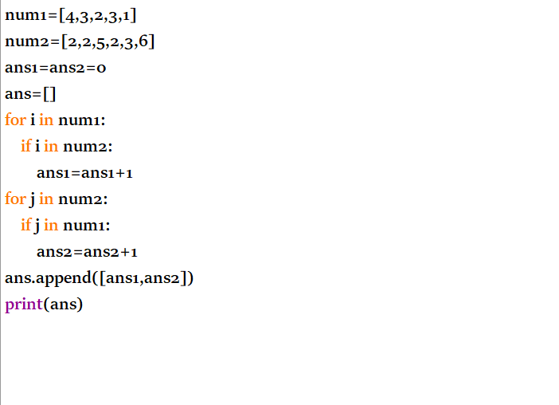
OUTPUT
Time Complexity: O(n × m)
Space Complexity: O(1)
3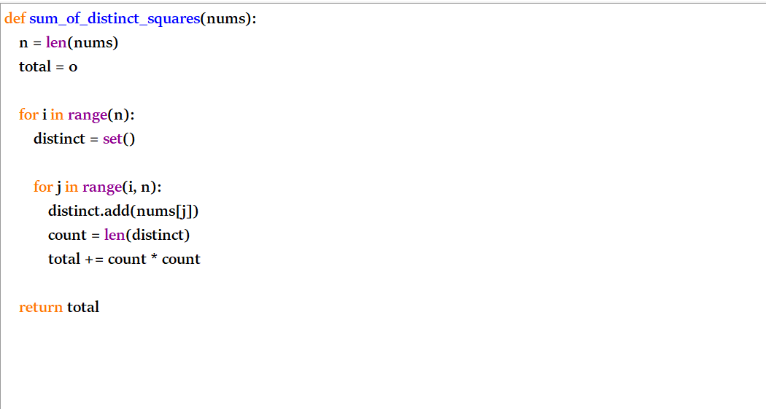
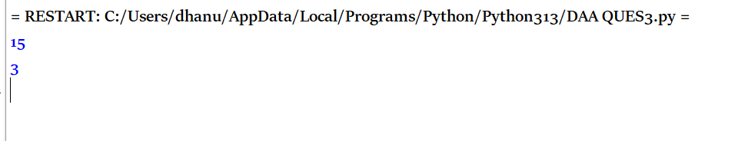
TIME COMPLEXITY: O(n²)
SPACE COMPLEXITY:O(n)
4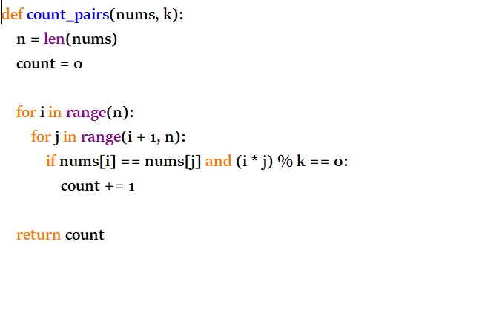
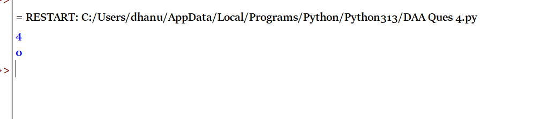
Time Complexity: O(n²)
Space Complexity:O(1)
5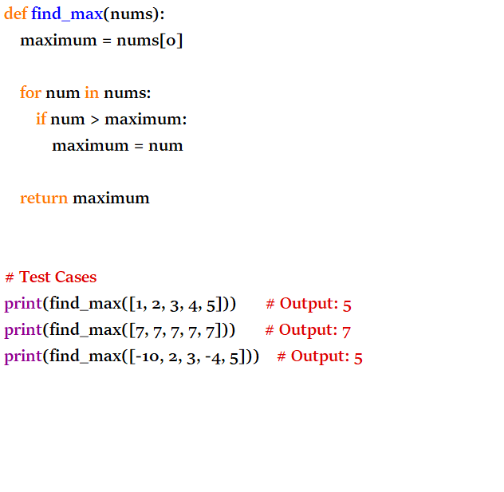
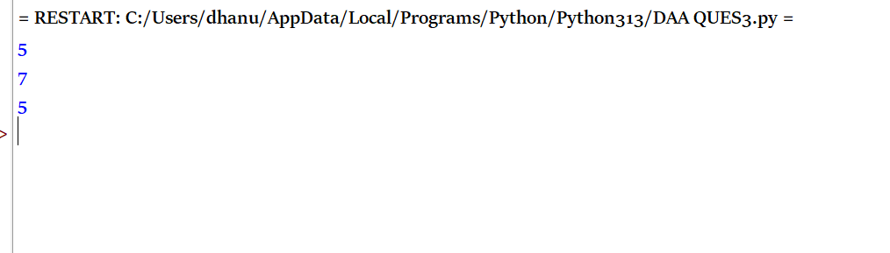
TIME COMPLEXITY:O(n)
SPACE COMPLEXITY:O(1)
6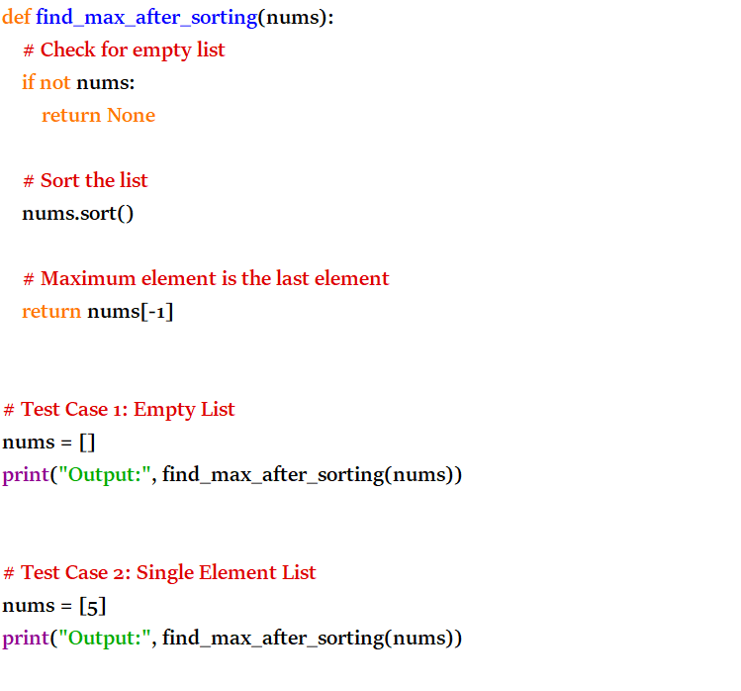
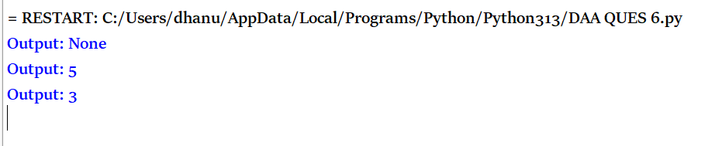
TIME COMPLEXITY: O(n log n)
SPACE COMPLEXITY: O(n)
7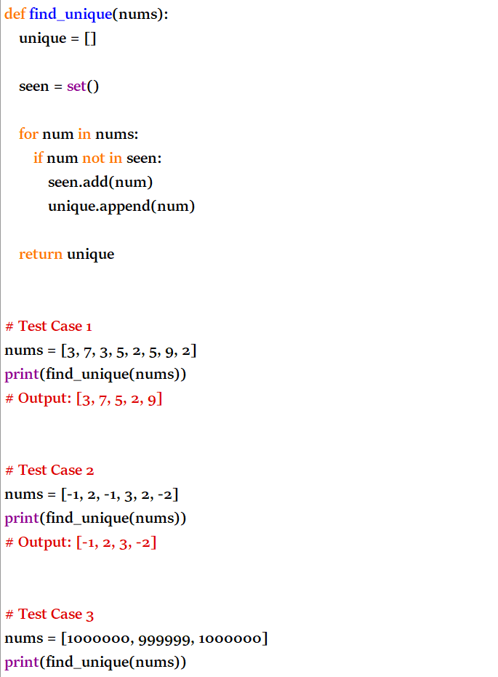
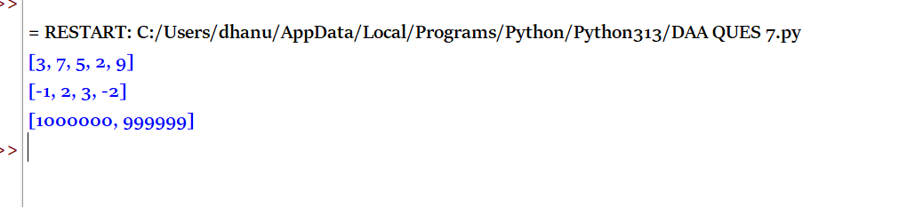
TIME COMPLEXITY: O(n)
SPACE COMPLEXITY: O(n)
8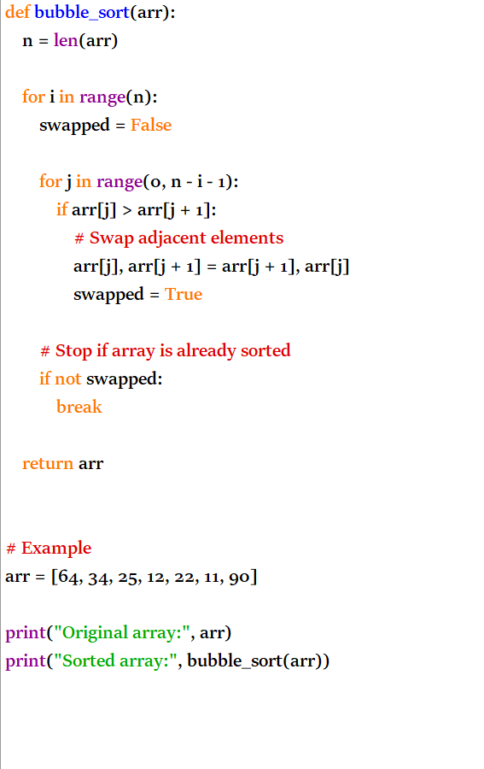
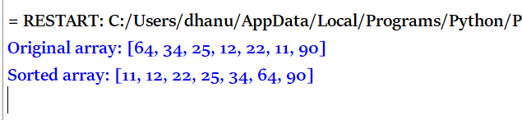
TIME COMPLEXITY: O(n²)
SPACE COMPLEXITY: O(1)
9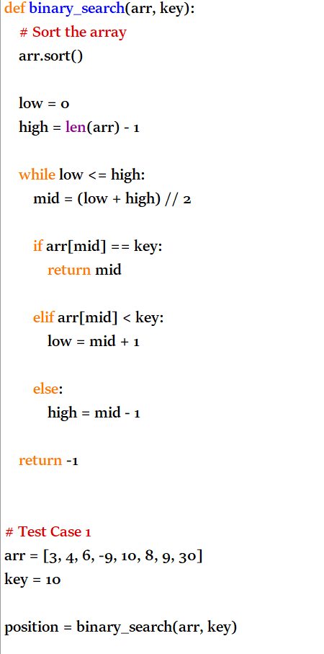
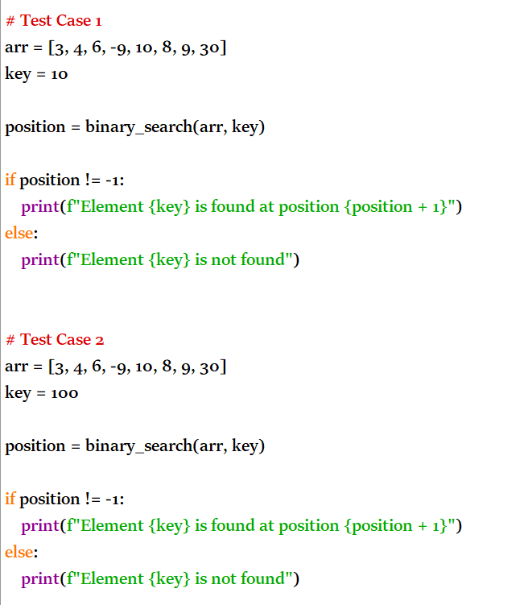
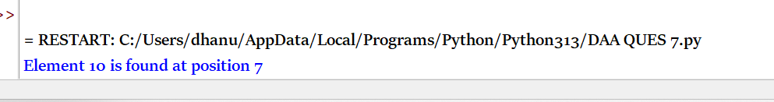
TIME COMPLEXITY: O(n log n)
SPACE COMPLEXITY:O(1)
10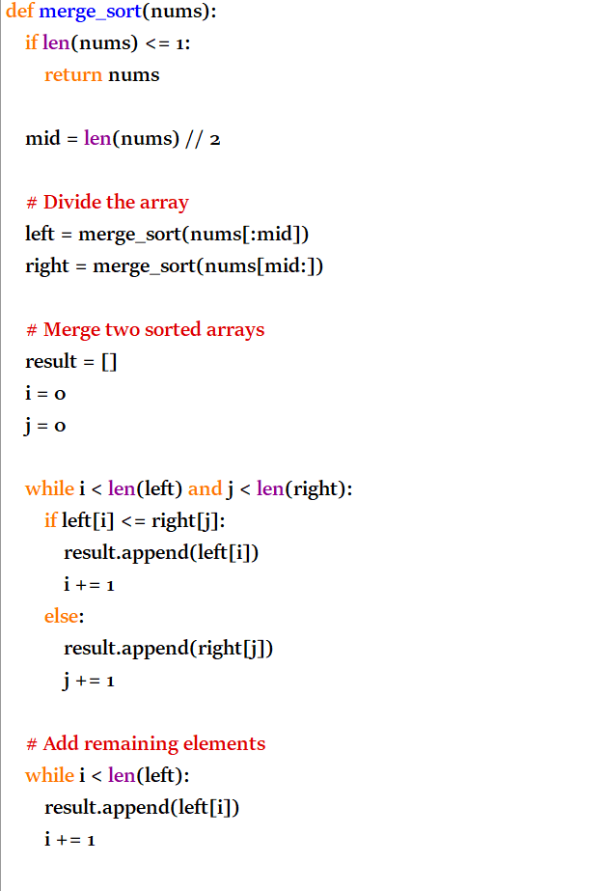
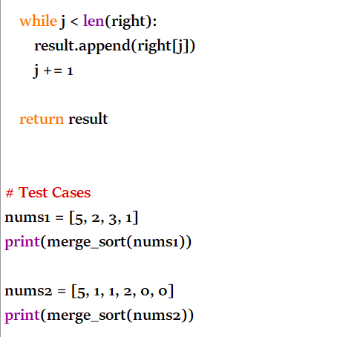
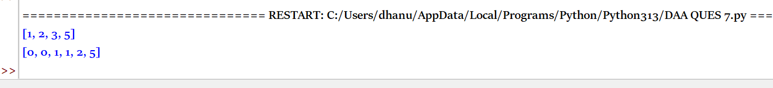

TOPIC 5
1

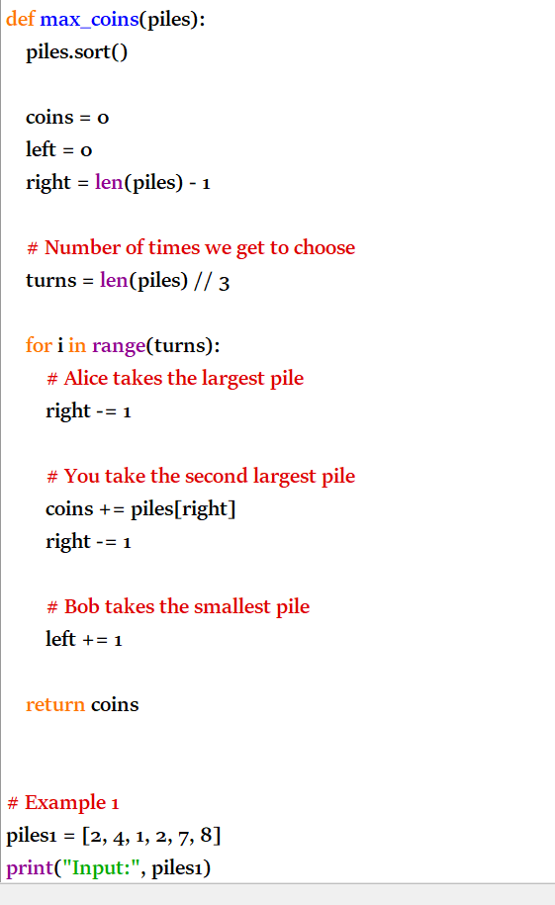

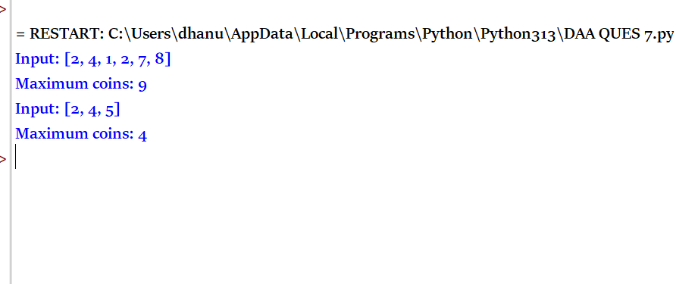
Overall Time Complexity: O(n log n)
Space Complexity: O(1)

2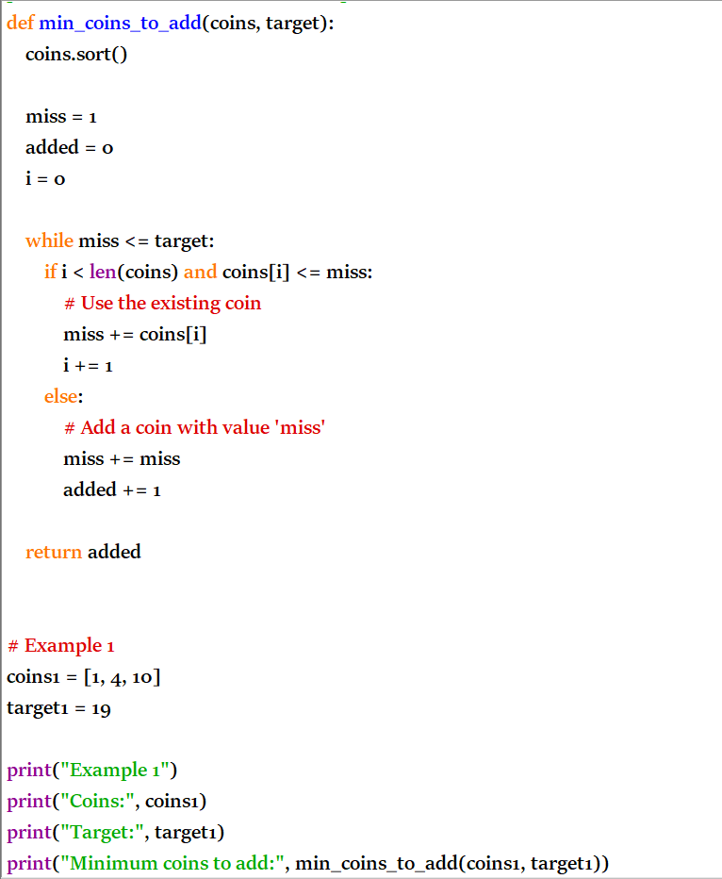
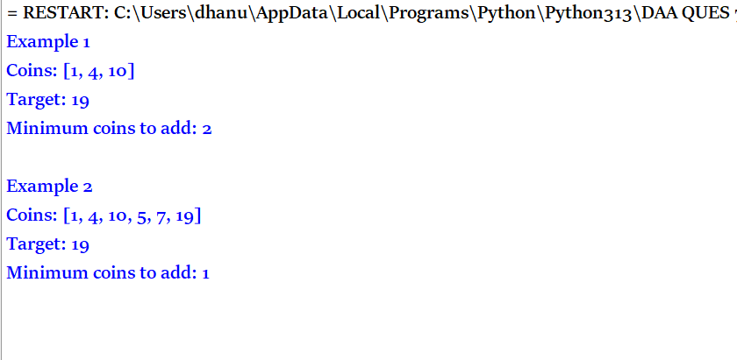
Time complexity: O(n log n)
Space complexity: O(1)
3
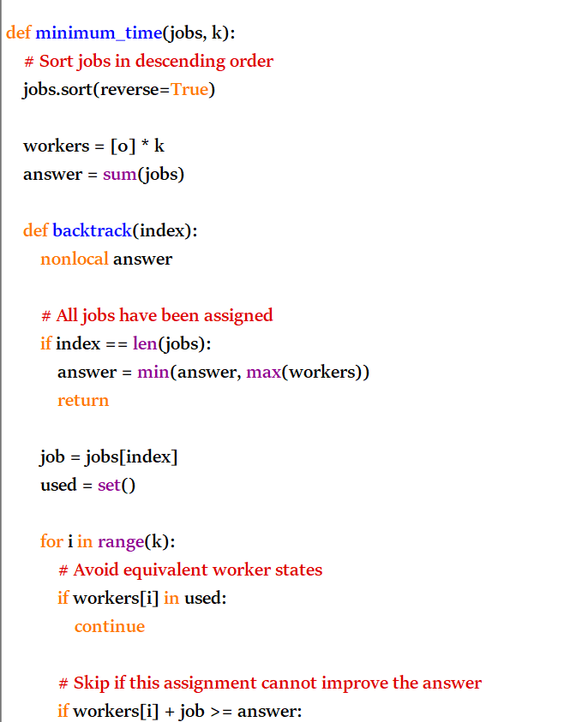
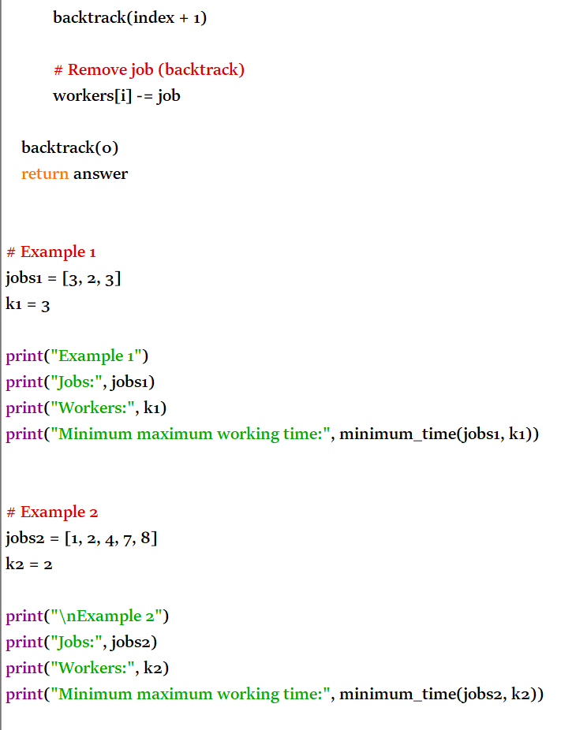
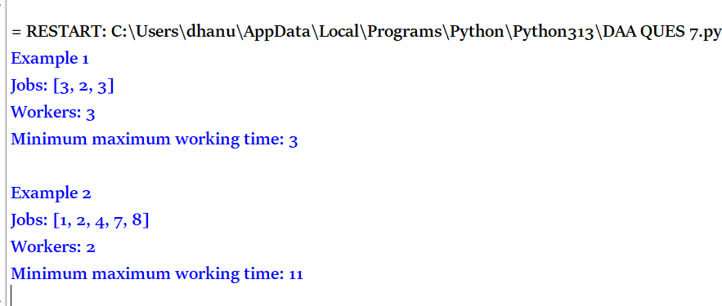
Time Complexity: O(k^n) in the worst case
Space Complexity: O(n + k)

4
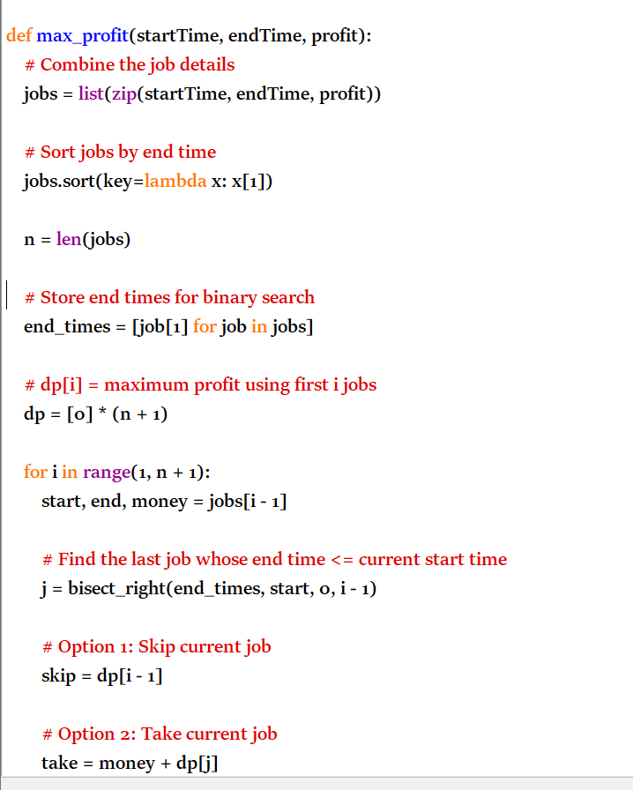
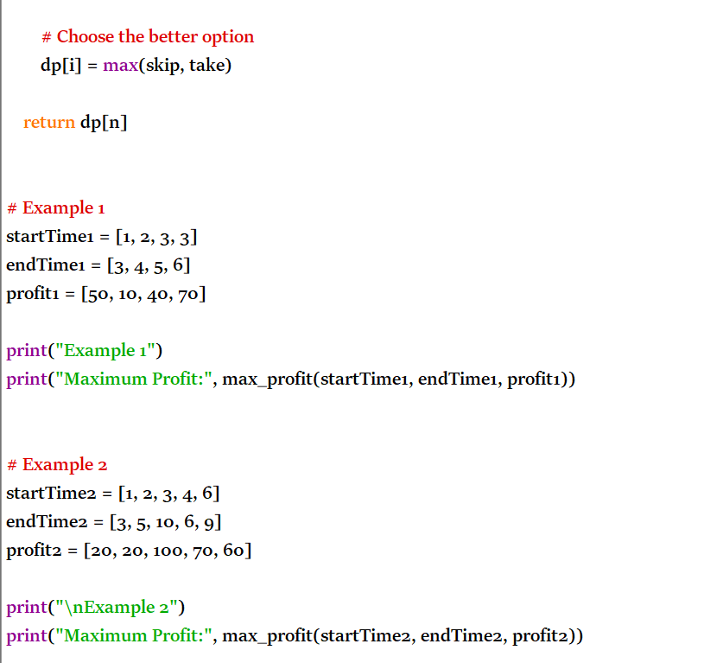
Time Complexity: O(n log n)
Space Complexity: O(n)
EXPERIMENT-11
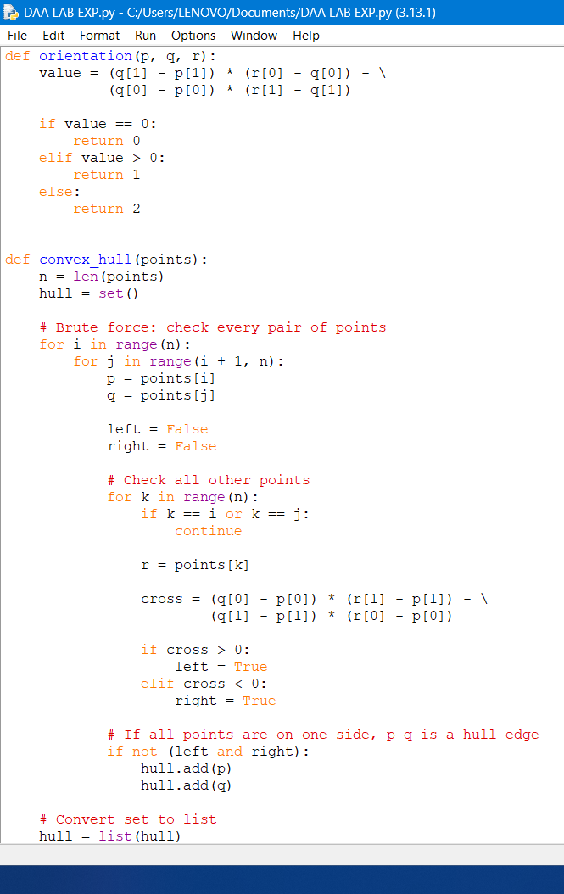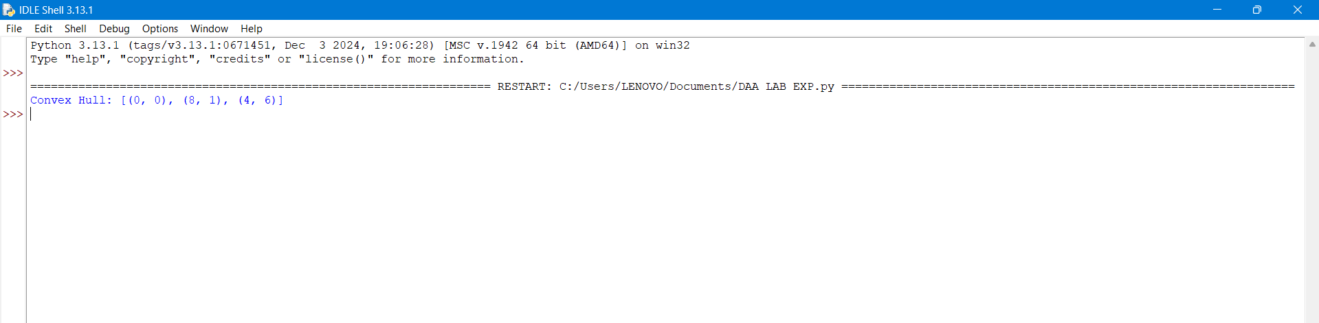
For the brute-force Convex Hull algorithm:
Time Complexity: O(n³)
Reason:
- Choose every pair of points → O(n²)
- For each pair, check all other points → O(n)
- Therefore:
O(n²) × O(n) = O(n³)
The final sorting of hull points takes O(h log h), where h ≤ n, so it doesn't dominate the O(n³) brute-force process.
Space Complexity: O(n)
- We store the convex hull points → at most n points.
- Therefore, auxiliary/output space is O(n).
Final Answer
Complexity | Value
Time Complexity | O(n³)
Space Complexity | O(n)
Best line to write in your record/exam:
The brute-force convex hull algorithm has O(n³) time complexity and O(n) space complexity.
EXPERIMENT-12

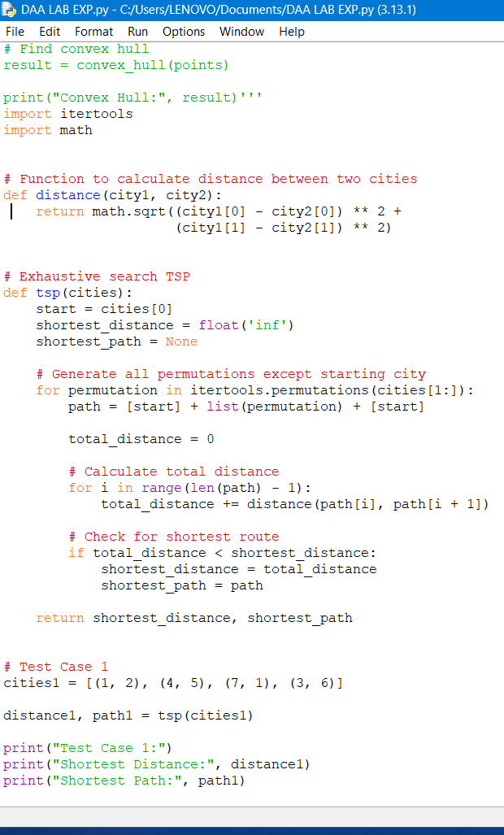
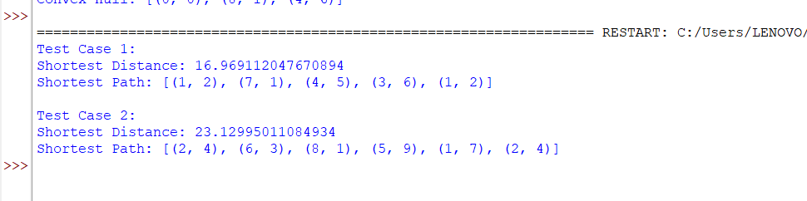
For the TSP using Exhaustive Search:
Time Complexity: O(n! × n)
Reason:
- Number of possible permutations = (n − 1)!
- For each permutation, we calculate the total route distance by checking n cities.
- Therefore:
O((n − 1)! × n) = O(n!)
So, the commonly stated time complexity is:
O(n!)
Space Complexity: O(n)
- Store each permutation/path → O(n)
- Store the shortest path → O(n)
- itertools.permutations() generates permutations one at a time rather than storing all of them.
Space Complexity = O(n)
Final Answer
Complexity | Value
Time Complexity | O(n! × n) ≈ O(n!)
Space Complexity | O(n)
For your record:
The exhaustive-search TSP algorithm has O(n! × n) time complexity and O(n) space complexity.
EXPERIMENT-13
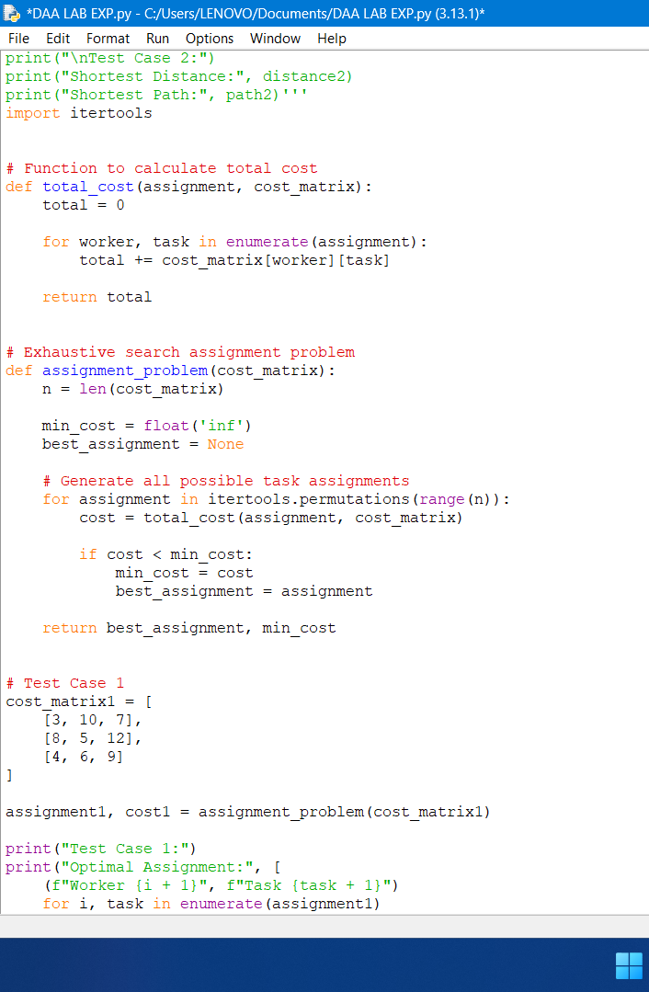
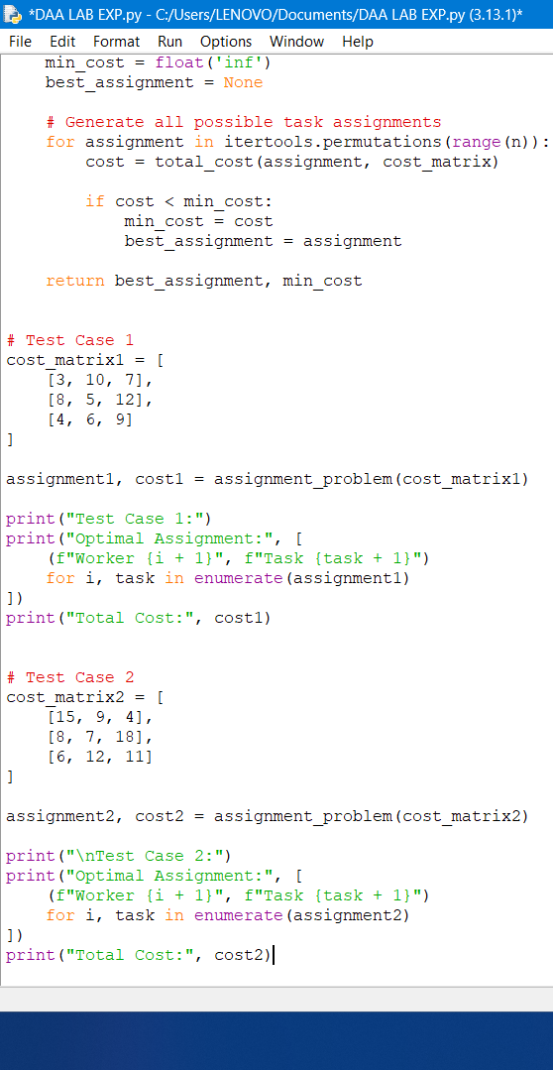
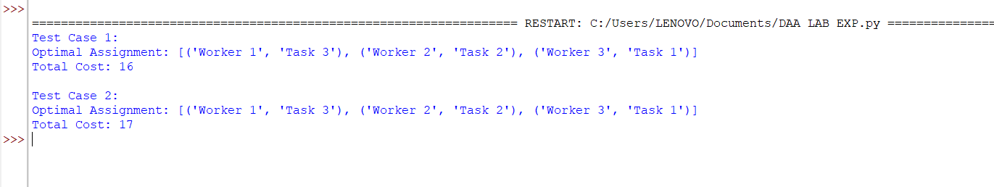
Time Complexity
There are n! permutations of task assignments.
For each permutation, calculating the total cost requires O(n) operations.
Therefore:
Time Complexity = O(n × n!)
Commonly written as O(n!) for exhaustive-search assignment problems, but O(n × n!) is the more precise complexity for this implementation.
Space Complexity
The algorithm stores:
- Current assignment → O(n)
- Best assignment → O(n)
- itertools.permutations() generates permutations one at a time.
EXPERIMENT-14
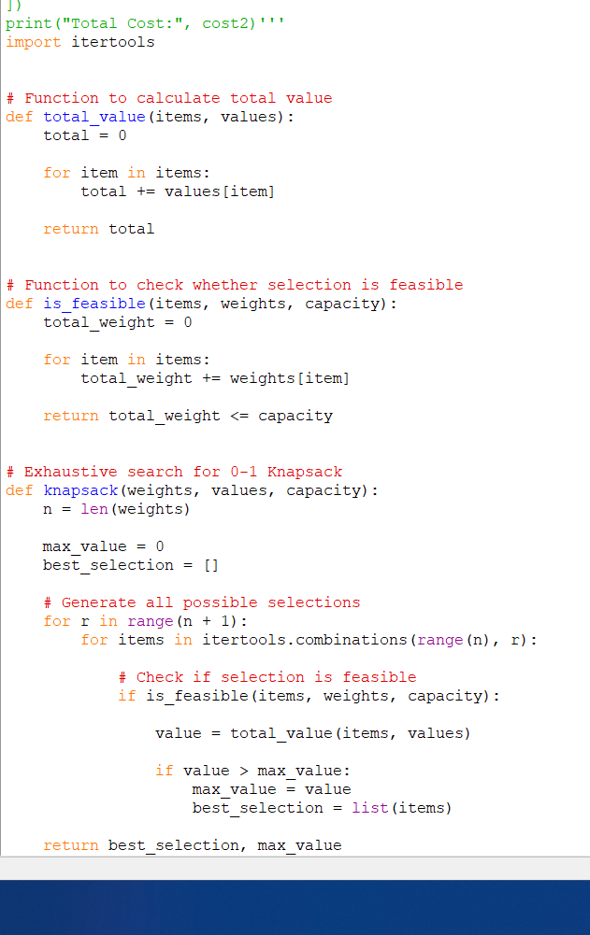
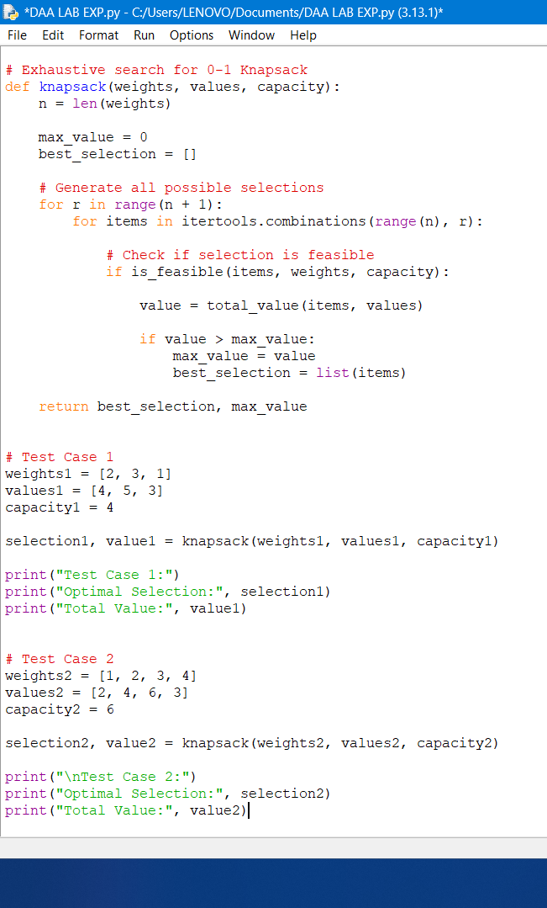
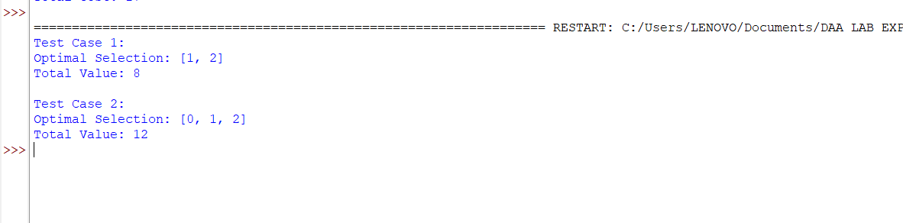

Time Complexity
For n items, there are 2ⁿ possible subsets.
For every subset:
- Check feasibility → O(n)
- Calculate total value → O(n)
Therefore:
Time Complexity = O(n × 2ⁿ)

Space Complexity
The algorithm stores the current/best selection of items, which requires at most O(n) space.
itertools.combinations() generates combinations one at a time.
Therefore:
Space Complexity = O(n)
Final Answer
Complexity | Value
Time Complexity | O(n × 2ⁿ)
Space Complexity | O(n)
The exhaustive-search 0-1 Knapsack algorithm has O(n × 2ⁿ) time complexity and O(n) space complexity.
EXPERIMENT-15
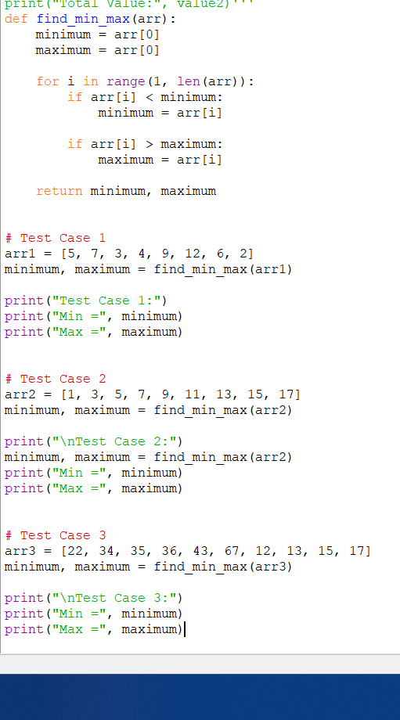
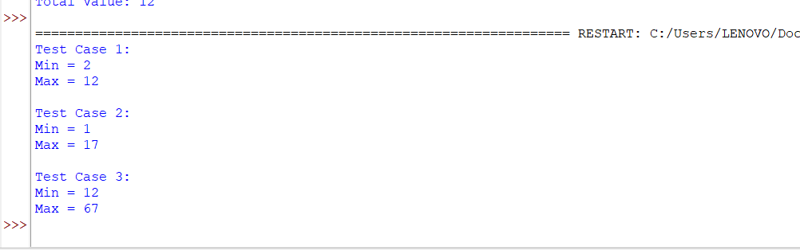
Time Complexity
The program traverses the array once.
For N elements:
Time Complexity = O(N)
Space Complexity
Only two variables, minimum and maximum, are used.
Space Complexity = O(1)
EXPERIMENT 16
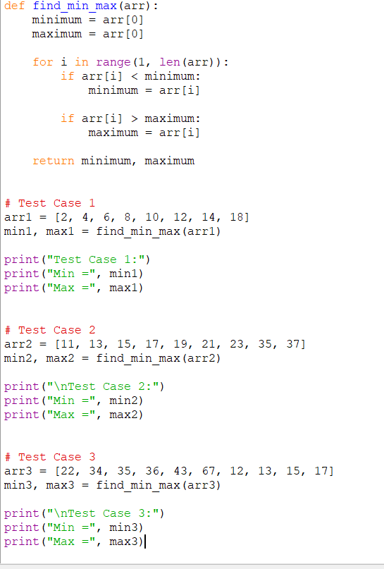
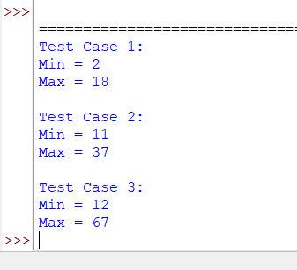
Time Complexity
The program checks every element once.
Time Complexity = O(N)
Space Complexity
Only two extra variables (minimum and maximum) are used.
Space Complexity = O(1)
EXPERIMENT-17
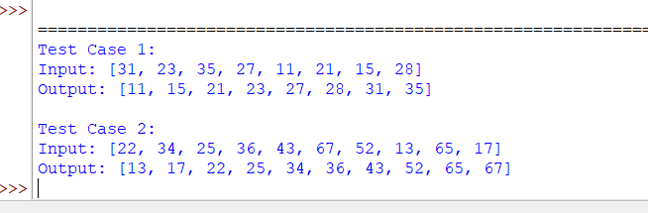
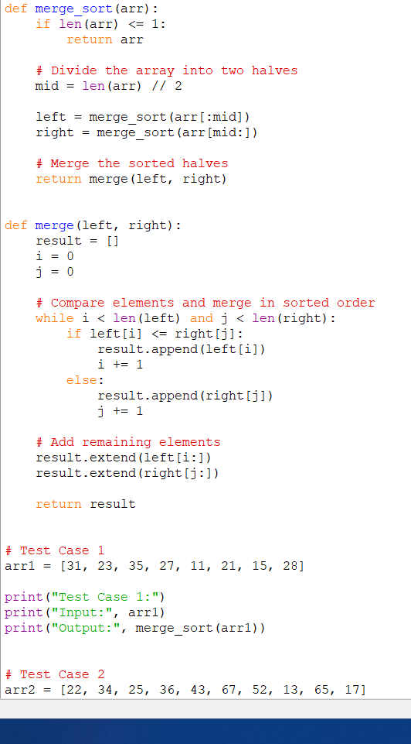
Time Complexity
- Dividing the array takes O(log N) levels.
- Merging at each level takes O(N).
Therefore:
Time Complexity = O(N log N)
Space Complexity
The temporary arrays created during merging require:
Space Complexity = O(N)
EXPERIMENT-18
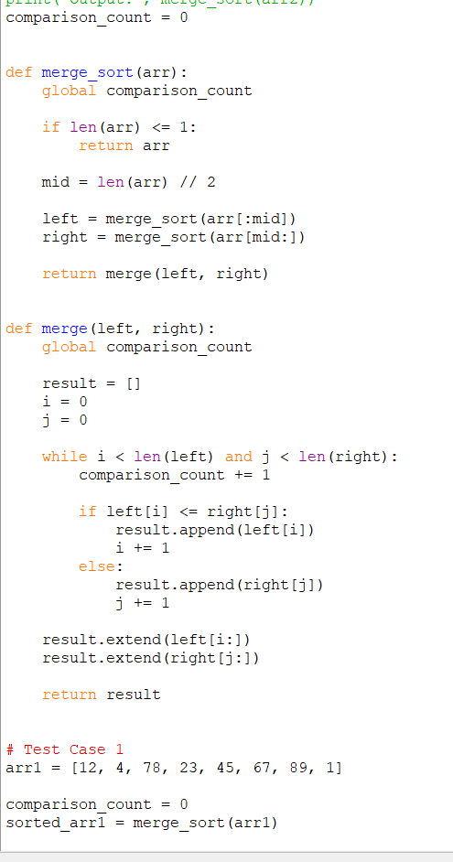
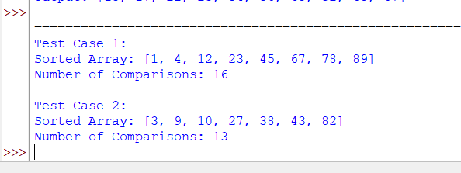
Time Complexity
Merge Sort divides the array into halves and merges them.
Time Complexity = O(N log N)
Space Complexity
Temporary arrays are used during merging.
Space Complexity = O(N)
EXPERIMENT-19
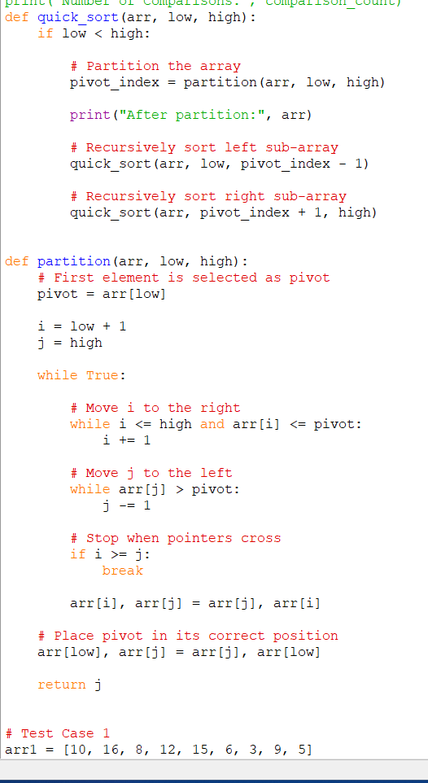
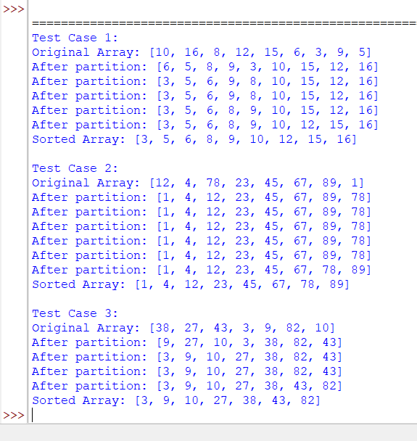
Time Complexity
Case | Time Complexity
Best Case | O(N log N)
Average Case | O(N log N)
Worst Case | O(N²)
Since the first element is always selected as pivot, an already sorted or nearly sorted array can produce the worst case.
Space Complexity
- Average recursion depth: O(log N)
- Worst-case recursion depth: O(N)
Therefore:
Average Space = O(log N)
Worst-case Space = O(N)
EXPERIMENT 20
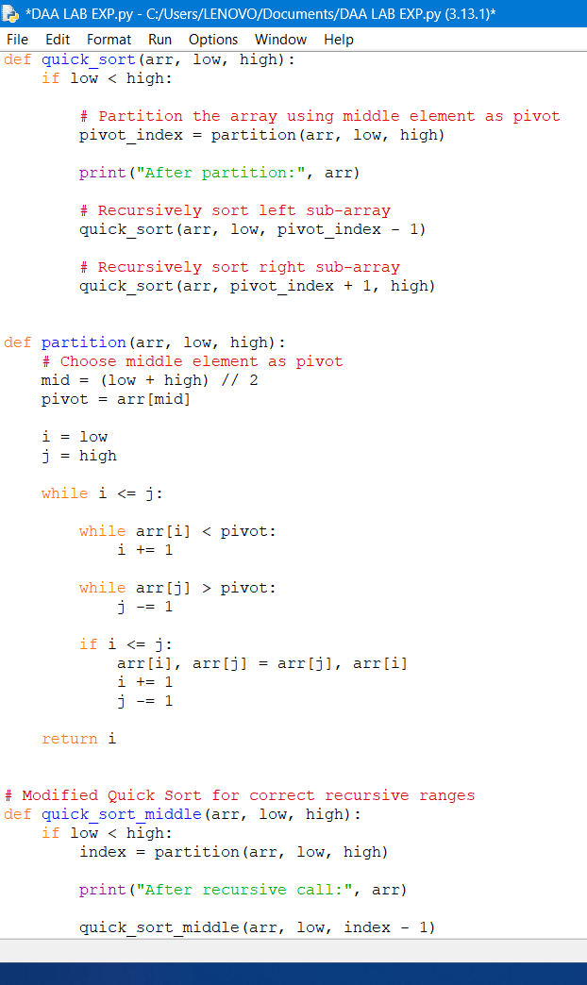
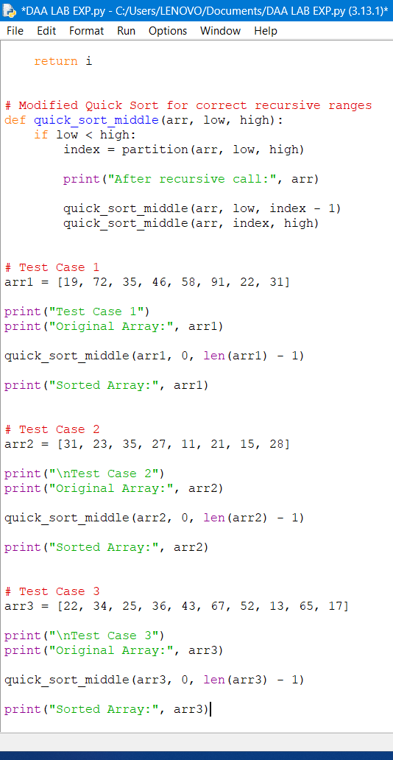
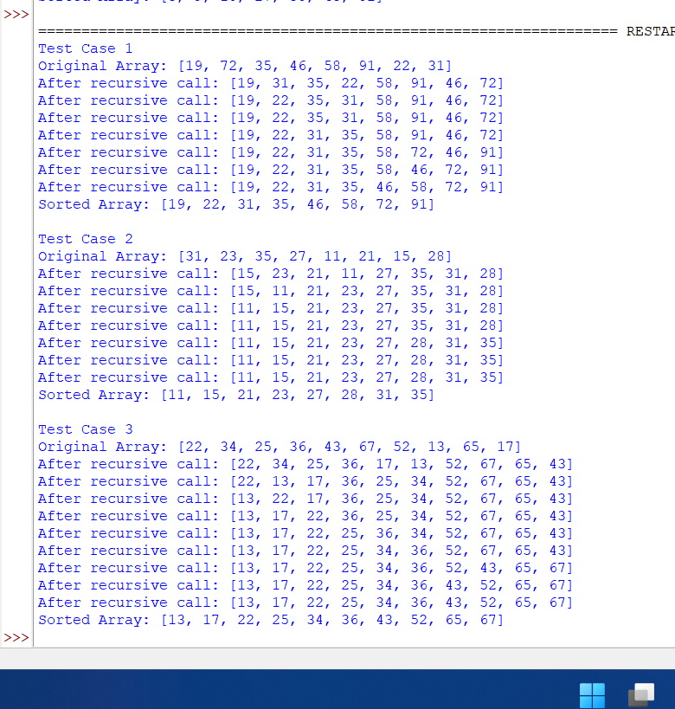
Complexity
Case | Time Complexity
Best Case | O(N log N)
Average Case | O(N log N)
Worst Case | O(N²)

Space Complexity:
- Average: O(log N)
- Worst: O(N)

LAB EXPERIMENTS

DAA-CSA0619
TOPIC 3: DIVIDE AND CONQUER

- Find Maximum and Minimum Using Divide and Conquer

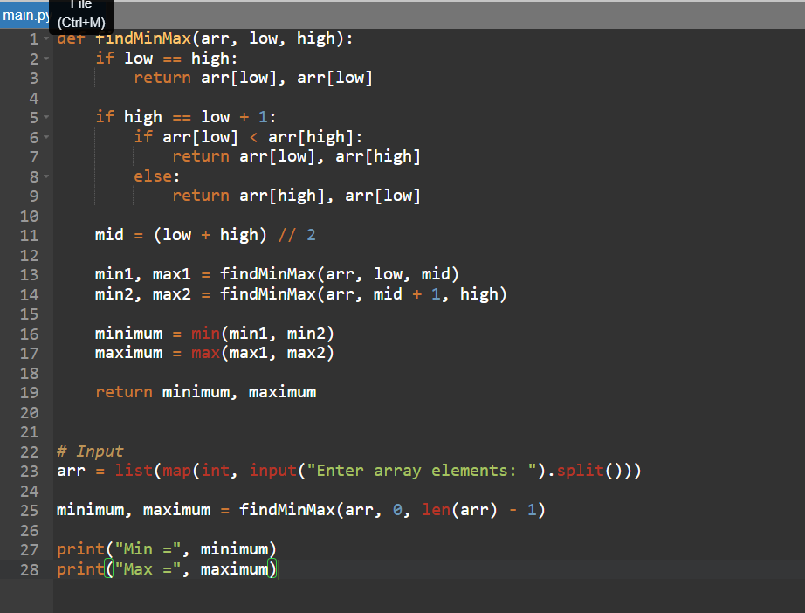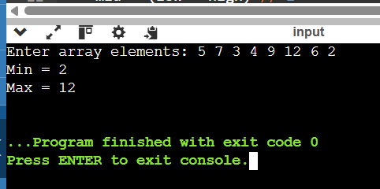
Time Complexity:
O(n)
Space Complexity:
O(log n) due to recursive calls.

2.Find Maximum and Minimum in a Sorted Array

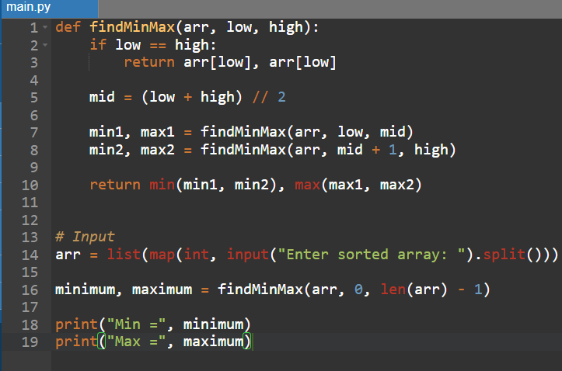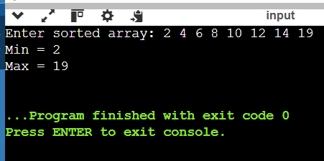

Time Complexity:
O(n)
Space Complexity:
O(log n)

3. Merge Sort
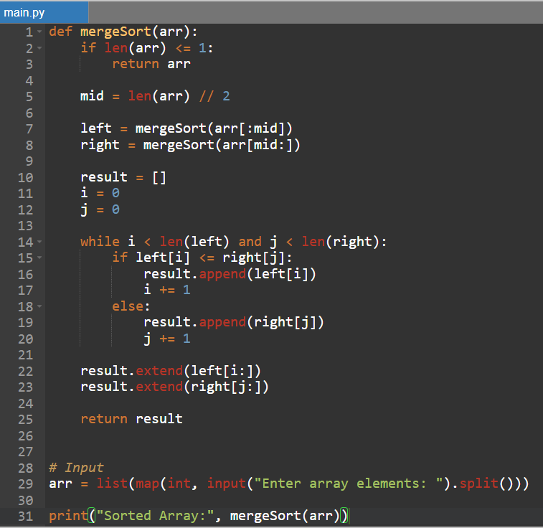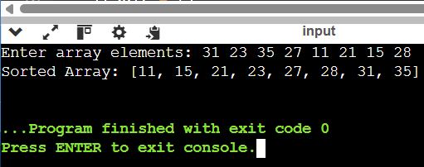
Time Complexity:
O(n log n)
Space Complexity:
O(n)

- Merge Sort with Comparison Count:

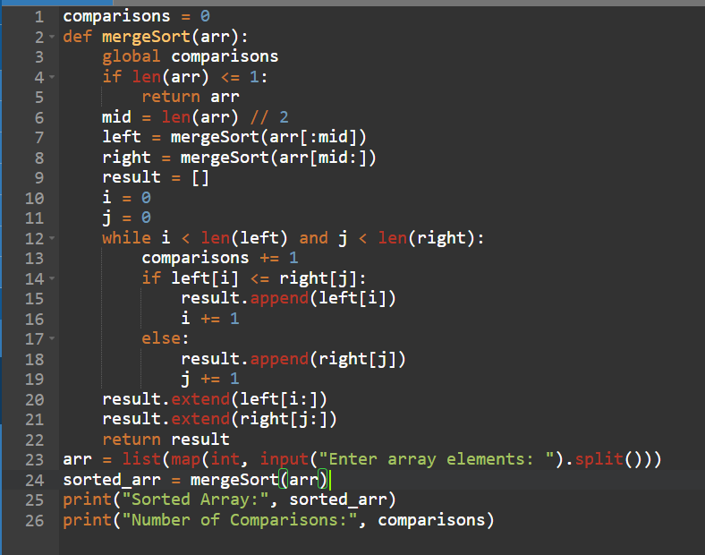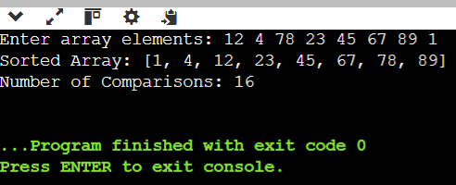
Time Complexity:
O(n log n)
Space Complexity:
O(n)

- Quick Sort – First Element as Pivot:

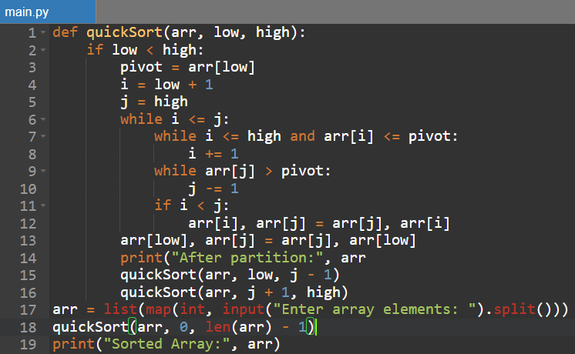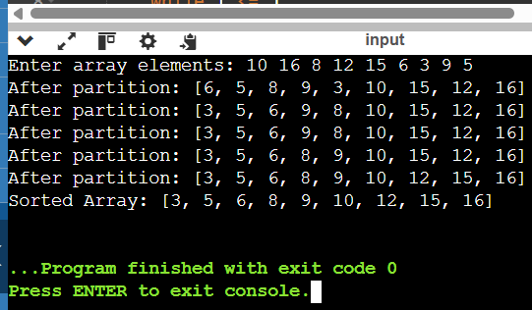
Time Complexity:
Best/Average: O(n log n)
Worst: O(n²)
Space Complexity:
O(log n) average due to recursion.

- Quick Sort – Middle Element as Pivot:

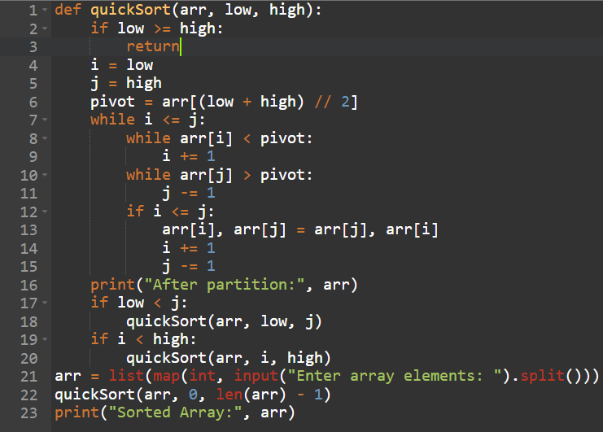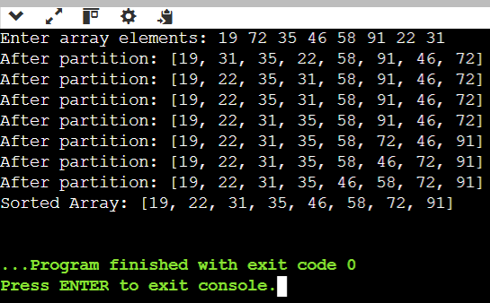
Time Complexity:
Best/Average: O(n log n)
Worst: O(n²)
Space Complexity:
O(log n) average due to recursion.

- Binary Search with Comparison Count:

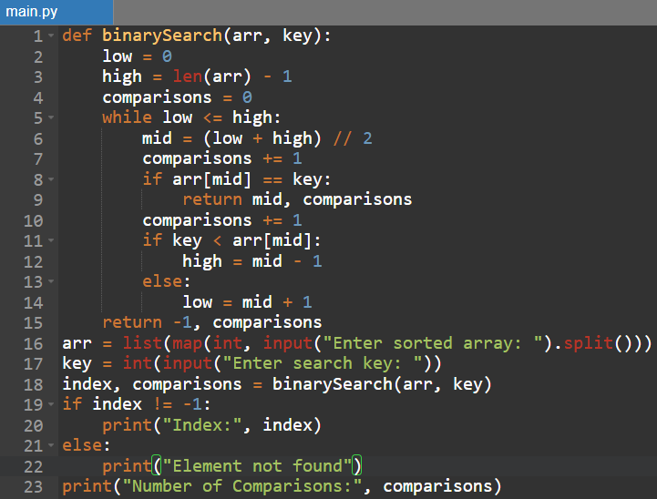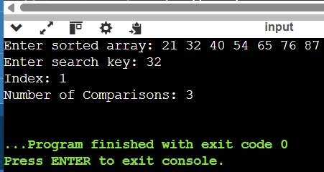

Time Complexity:
O(log n)
Binary Search eliminates half of the search space in every step.
Space Complexity:
O(1)

8. Binary Search with Mid-Point Steps:

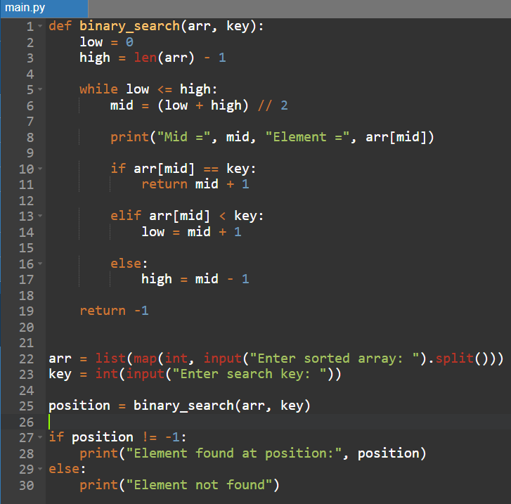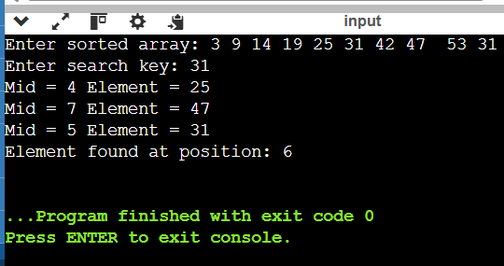
Time Complexity:
O(log n)
Space Complexity:
O(1)

9 . K Closest Points to Origin:

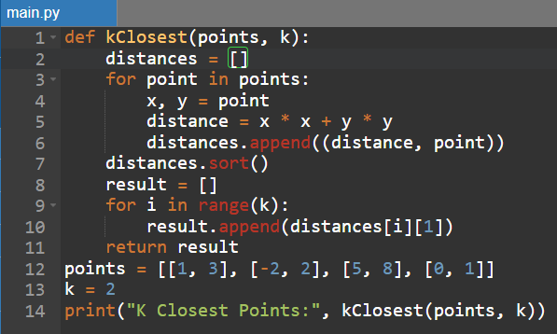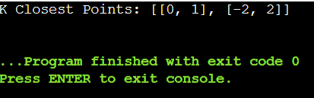
Time Complexity:
O(n log n)
Space Complexity:
O(1)

- Four Sum II:

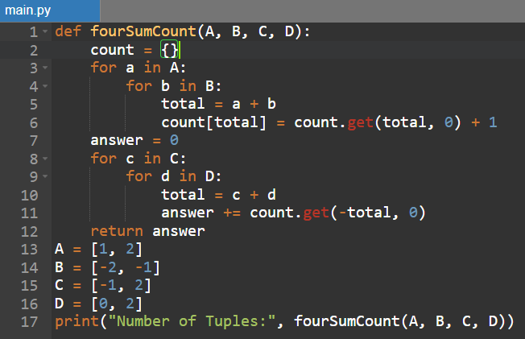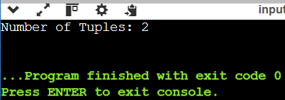
Time Complexity:
O(n²)
Space Complexity:
O(n²)

- Median of Medians :

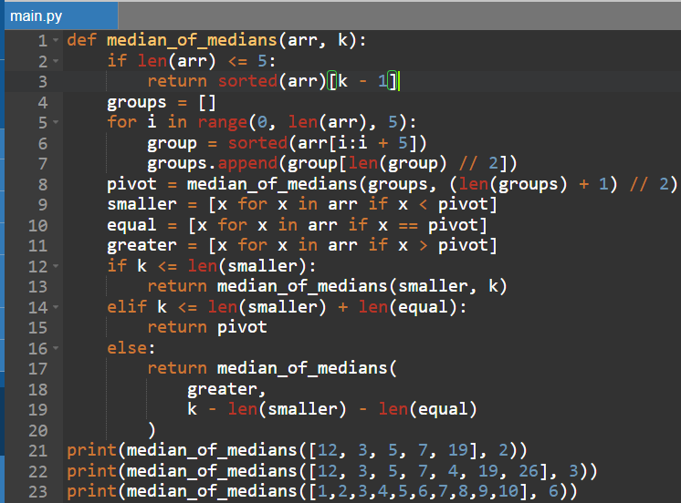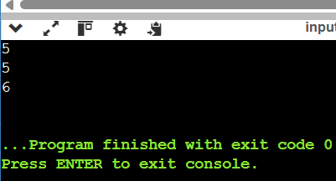
Time Complexity:
O(n) worst case.
Space Complexity:
O(n) for the auxiliary lists used.

- Median of Medians Function:

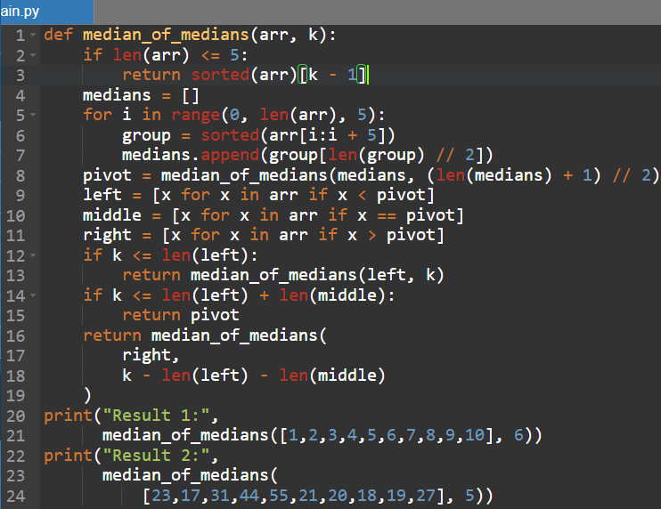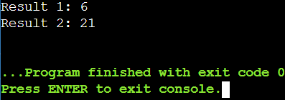
Time Complexity:
O(n) worst case.
Space Complexity:
O(n)

- Meet in the Middle – Closest Subset Sum:
Time Complexity:
O(2^(n/2)) approximately.
Space Complexity:
O(2^(n/2))
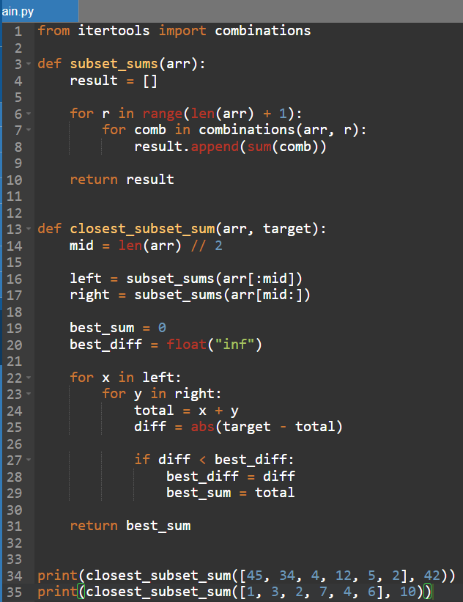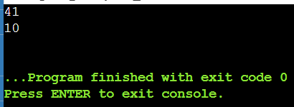

- Meet in the Middle – Exact Subset Sum:

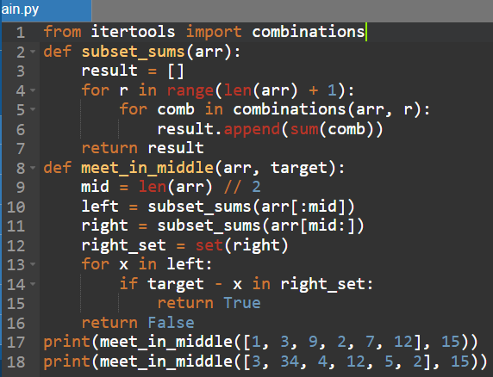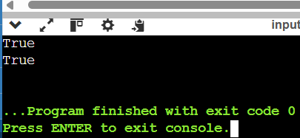
Time Complexity:
O(2^(n/2)) approximately.
Space Complexity:
O(2^(n/2))

- Strassen's Matrix Multiplication:

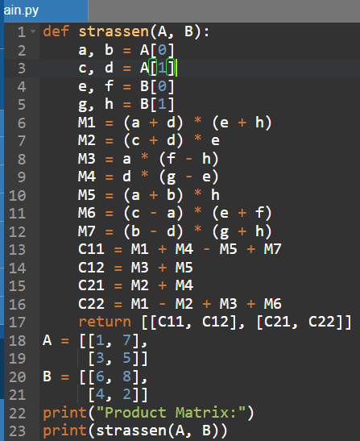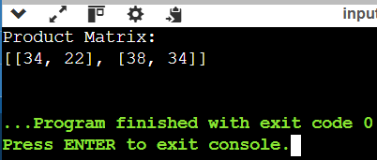
Time Complexity:
O(n^log₂7) ≈ O(n^2.807)
Space Complexity:
O(n²)

- Karatsuba Multiplication:

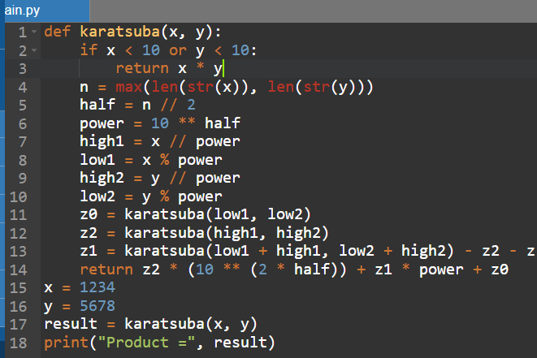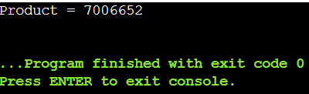

Time Complexity:
O(n^log₂3) ≈ O(n^1.585)
Space Complexity:
O(n) due to recursive calls.

3.

4.

5.

CSA0619-Design and Analysis of Algorithm
TOPIC-4
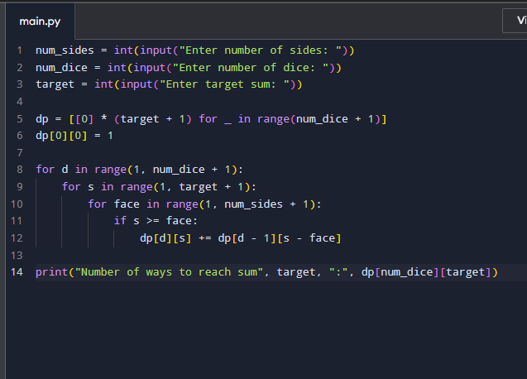
1

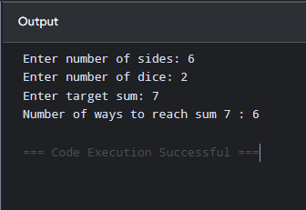

Time Complexity: O (num_dice × target × num_sides)
Space Complexity: O (num_dice × target)

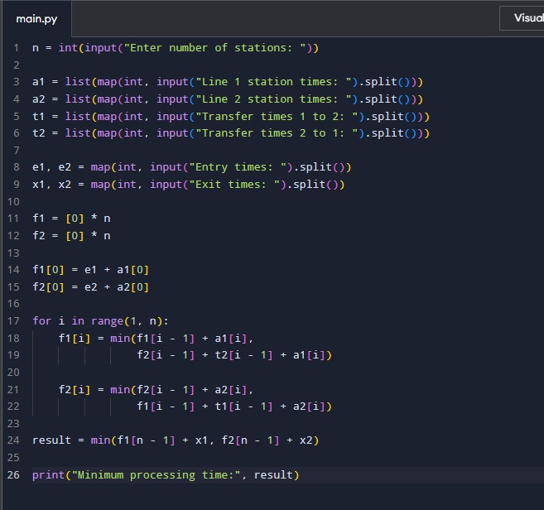
2,

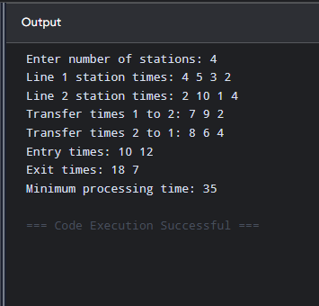

Time Complexity: O(n)
Space Complexity: O(n)

3, 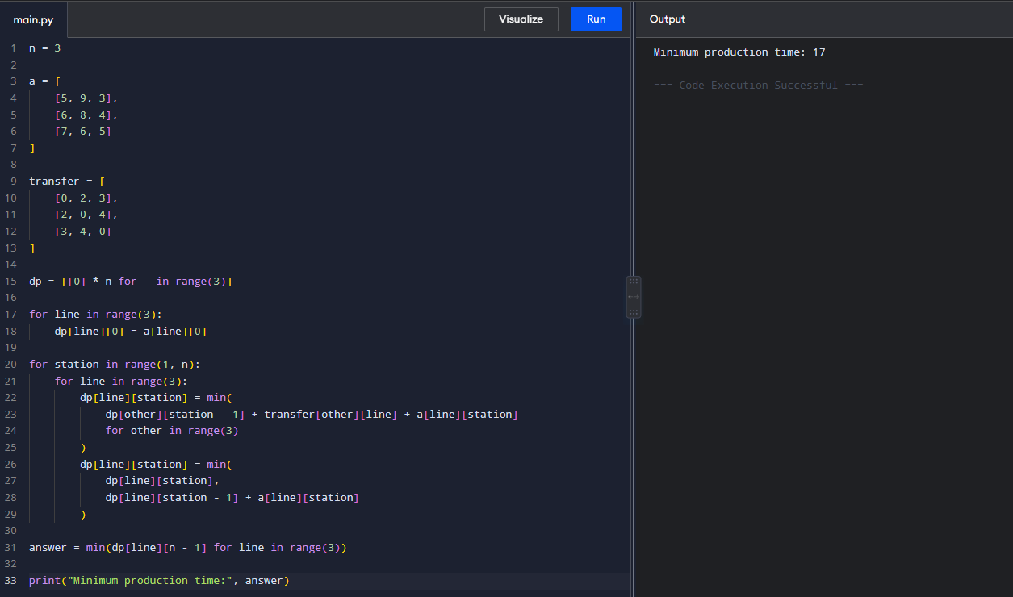
Time Complexity: O(n)
Space Complexity: O(n)
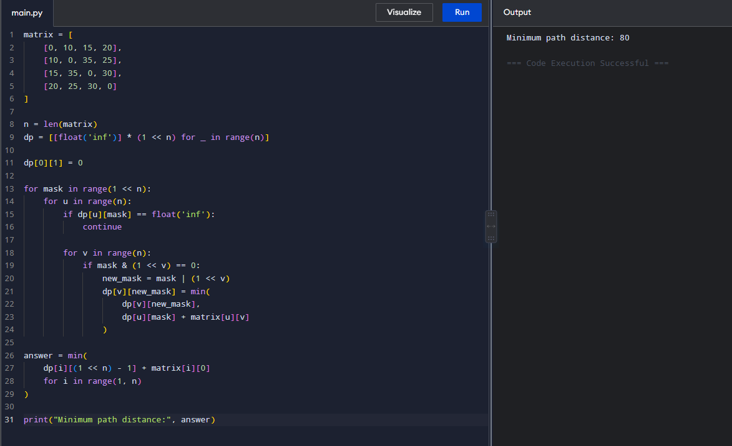
4,

Time Complexity: O(n² × 2ⁿ)
Space Complexity: O(n² × 2ⁿ)
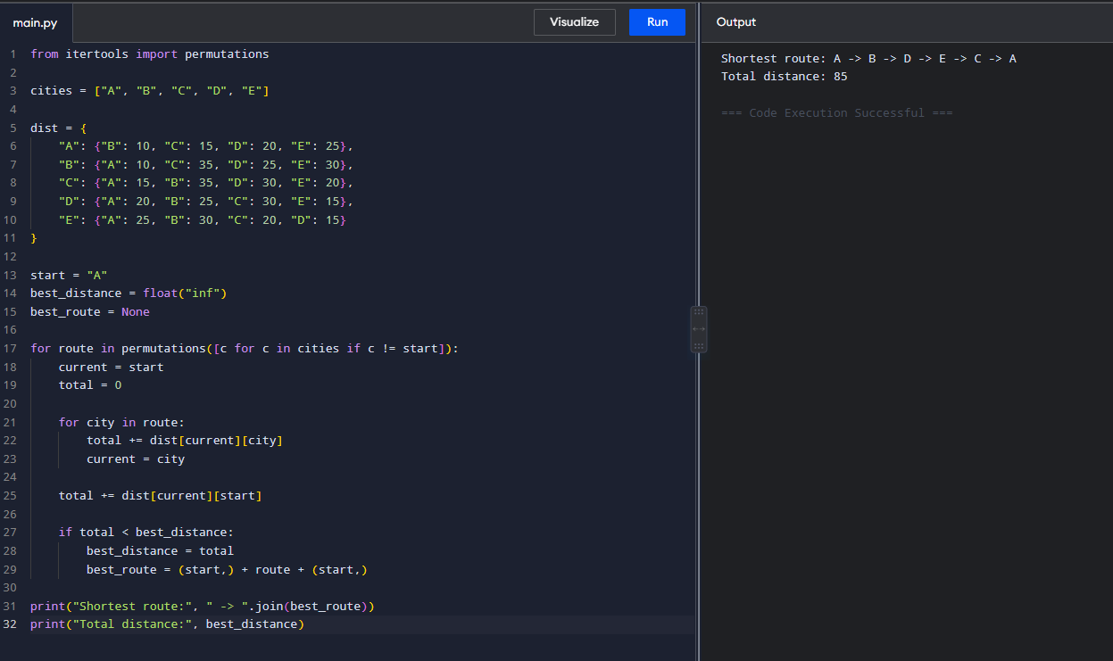
5,

Time Complexity: O(n!)
Space Complexity: O(n!)

6, 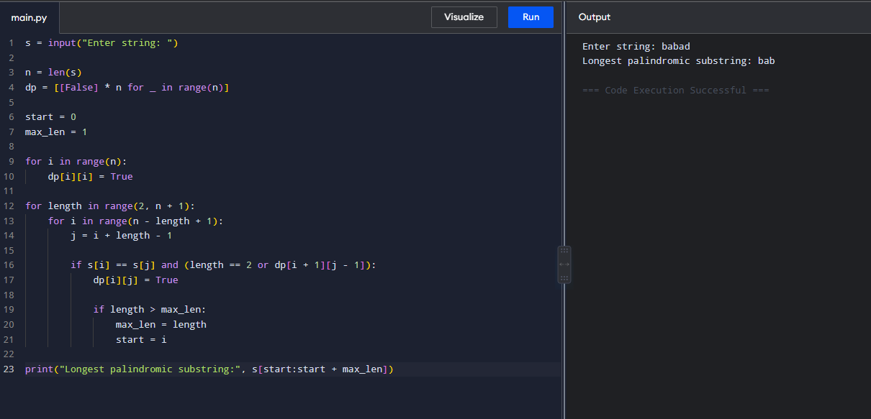
Time Complexity: O(n²)
Space Complexity: O(n²)

7, 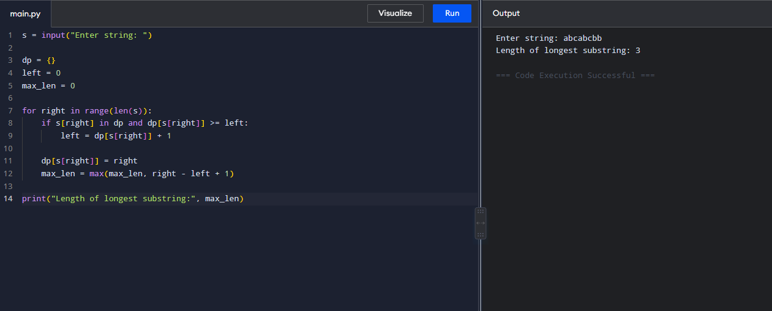
Time Complexity: O(n)
Space Complexity: O(n)

8, 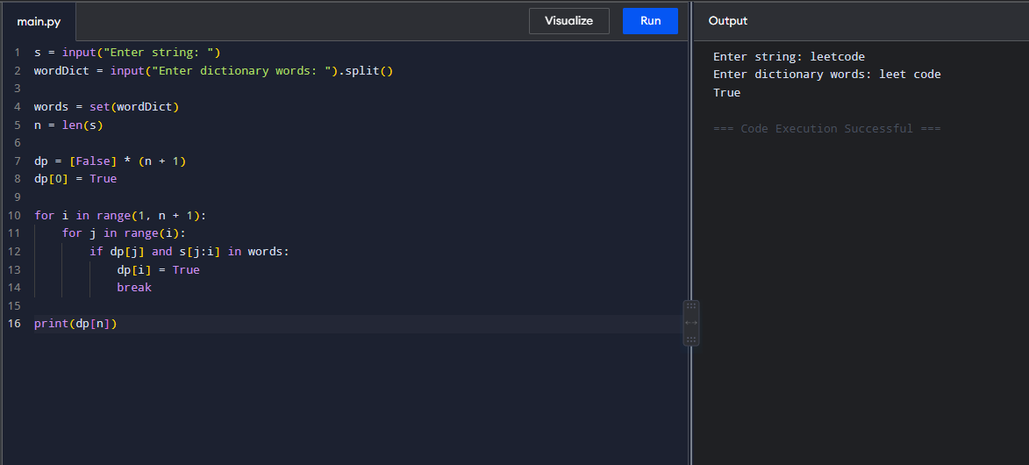
Time Complexity: O(n²)
Space Complexity: O(n)

9, 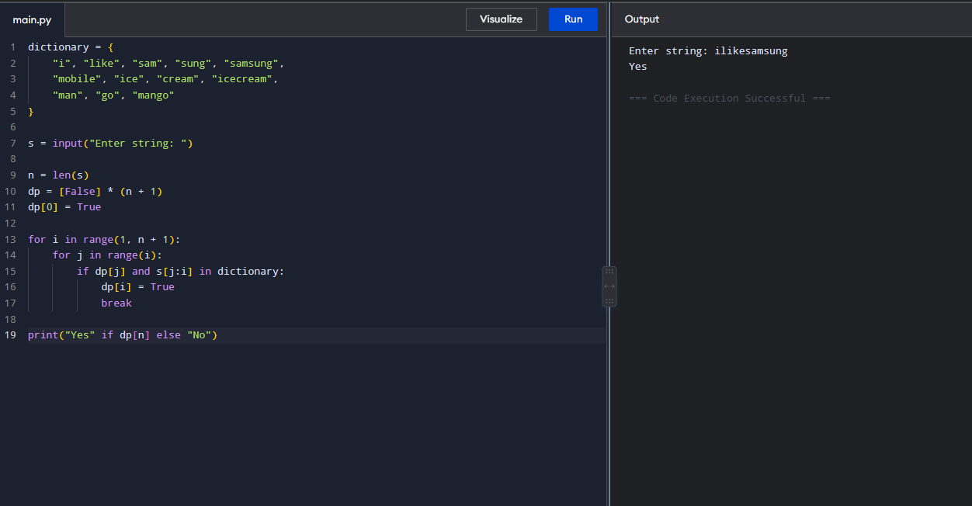
Time Complexity: O(n²)
Space Complexity: O(n)

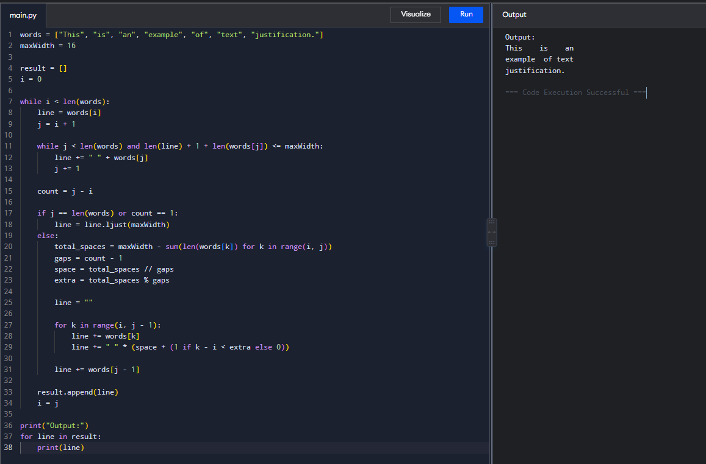
10,

Time Complexity: O(n)
Space Complexity: O(n)
11, 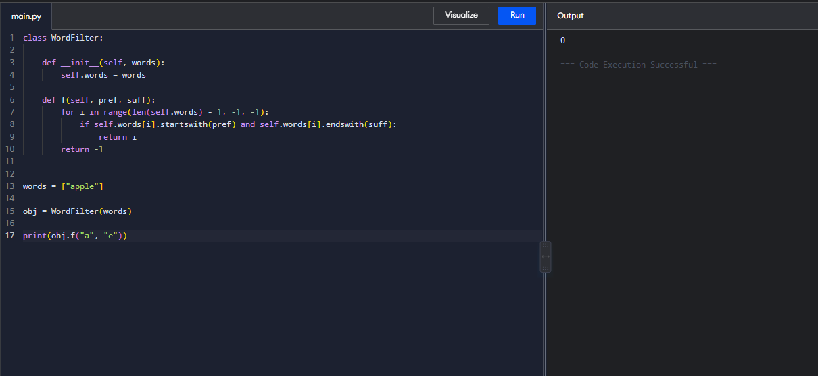
Time Complexity: O(n × L)
Space Complexity: O(n × L)

12, 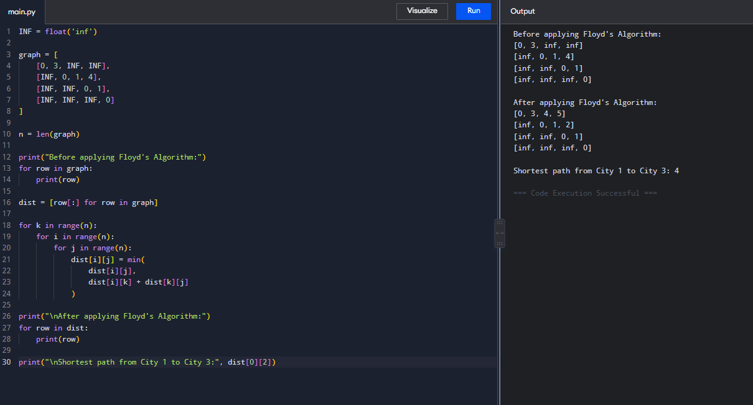
Time Complexity: O(n³)
Space Complexity: O(n²)

13, 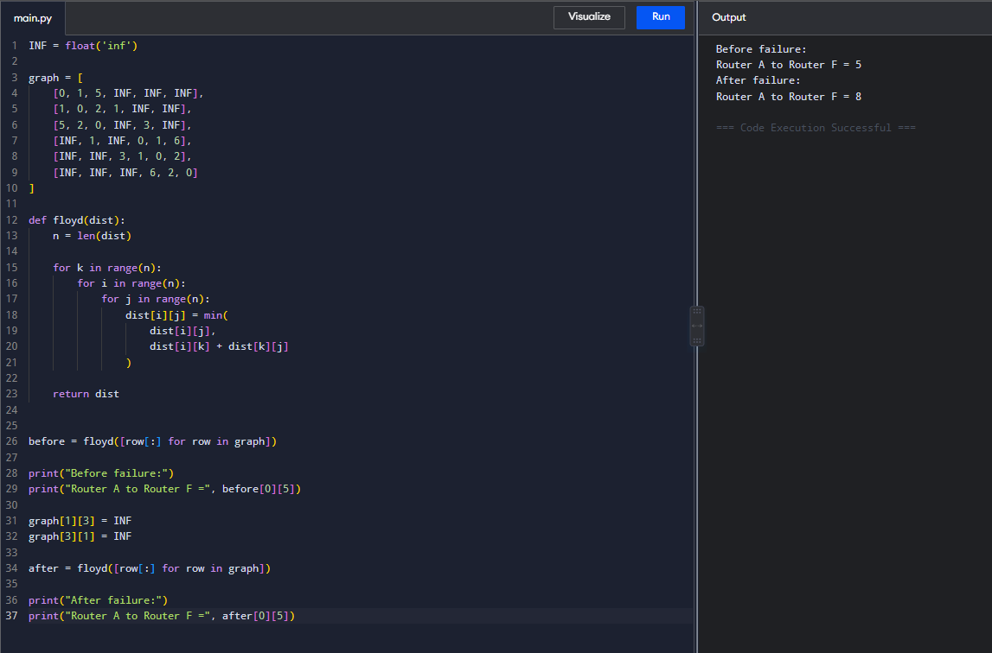
Time Complexity: O(n³)
Space Complexity: O(n²)

14, 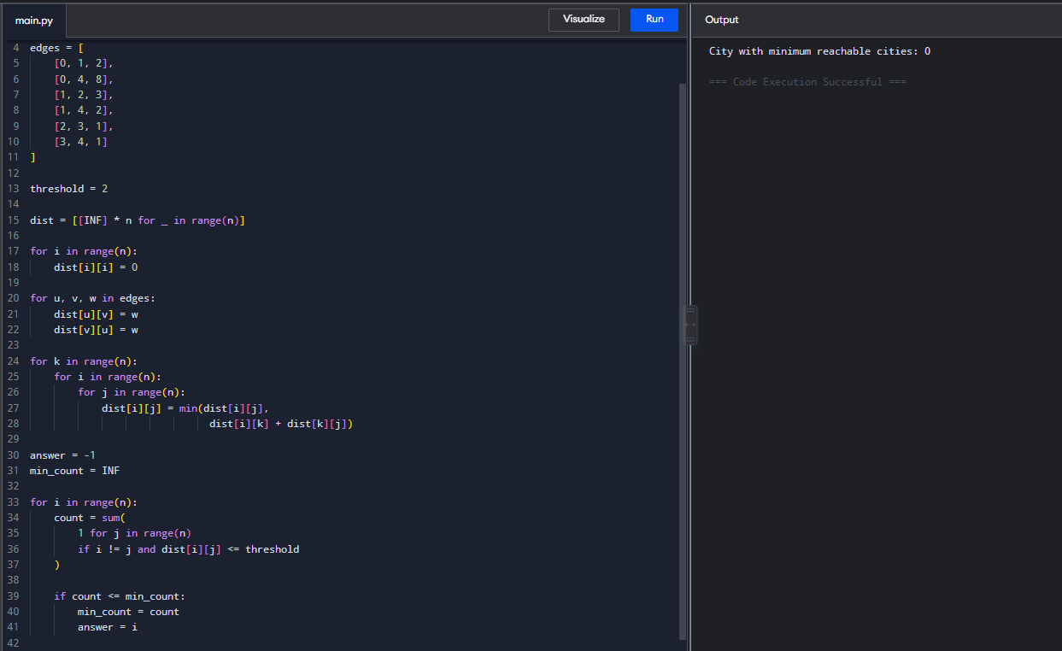
Time Complexity: O(n³)
Space Complexity: O(n²)

15, 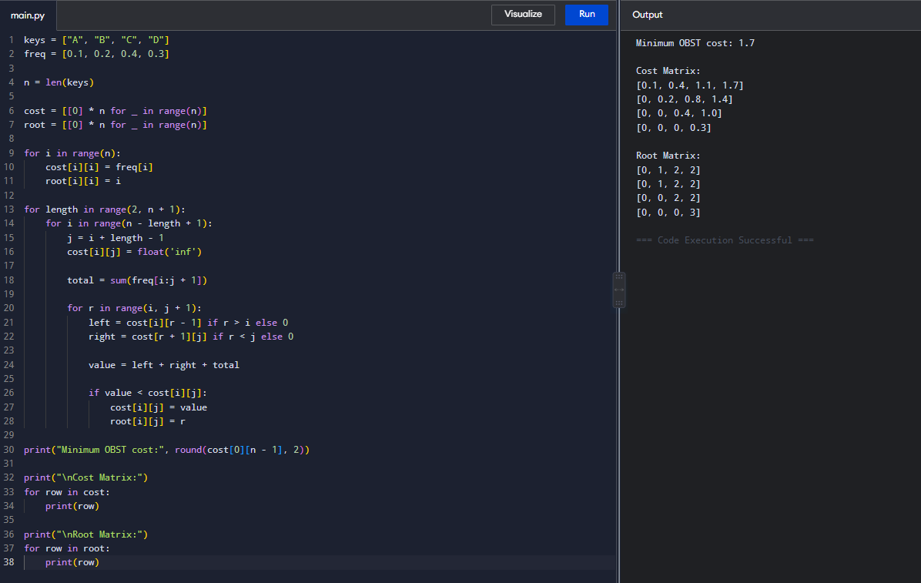
Time Complexity: O(n³)
Space Complexity: O(n²)

16, 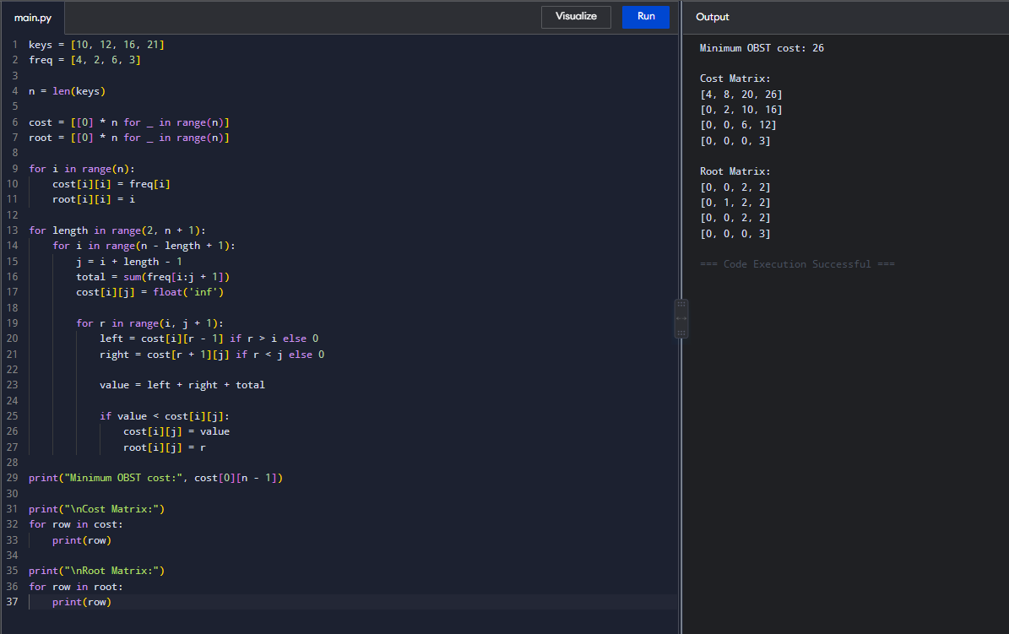
Time Complexity: O(n³)
Space Complexity: O(n²)
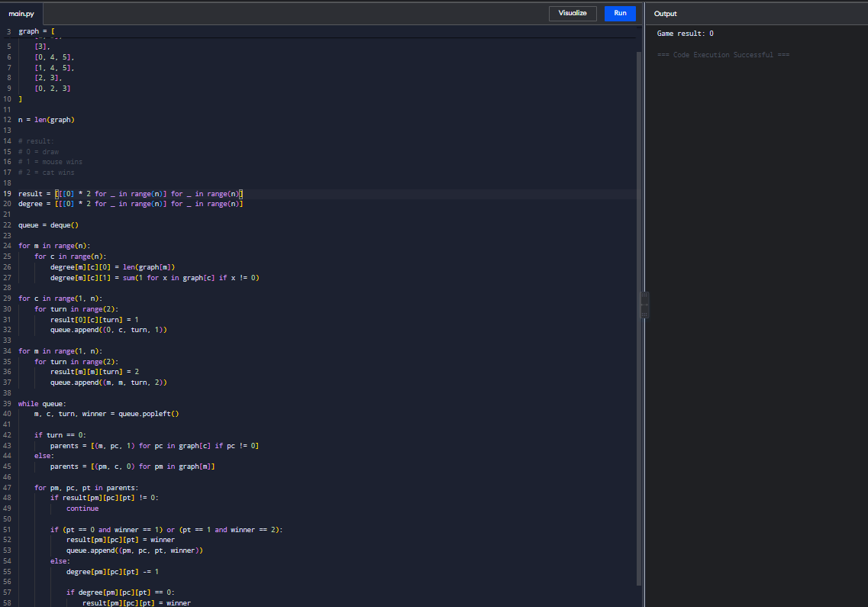
17,

Time Complexity: O(n³)
Space Complexity: O(n³)

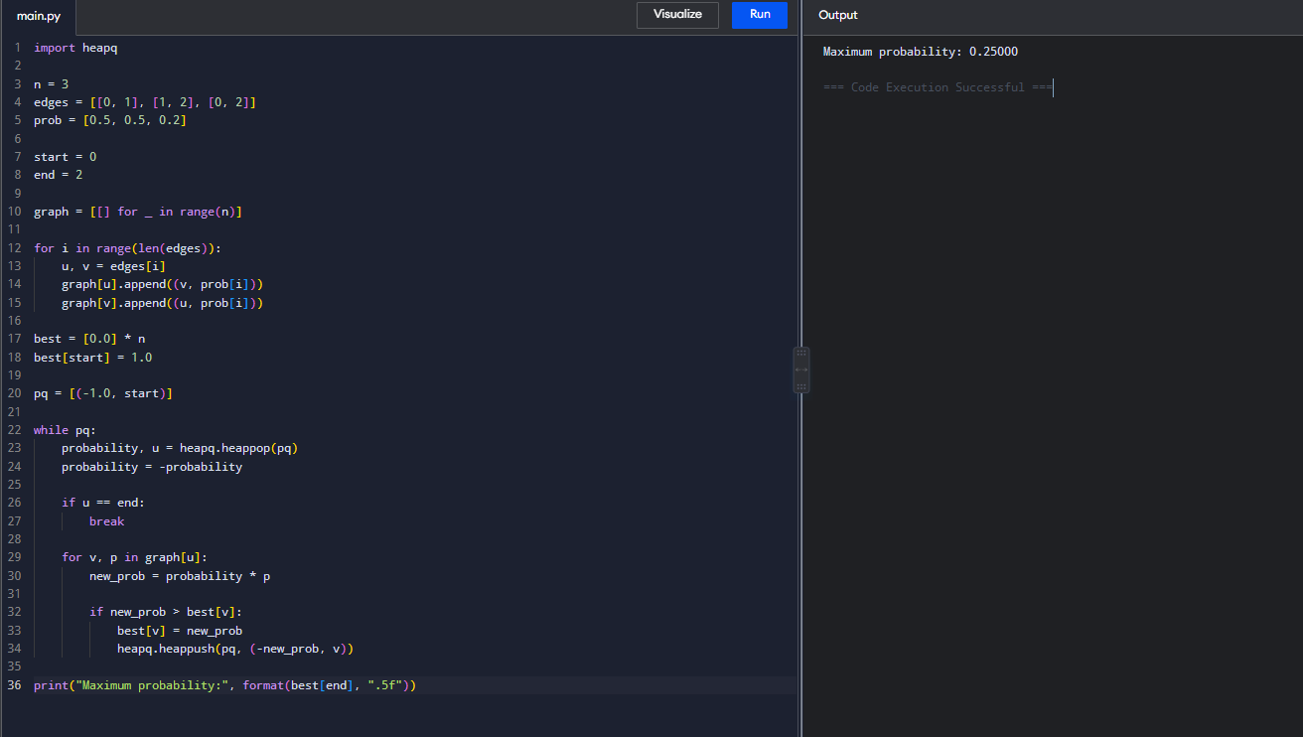
18,

Time Complexity: O((V + E) log V)
Space Complexity: O(V + E)

19, 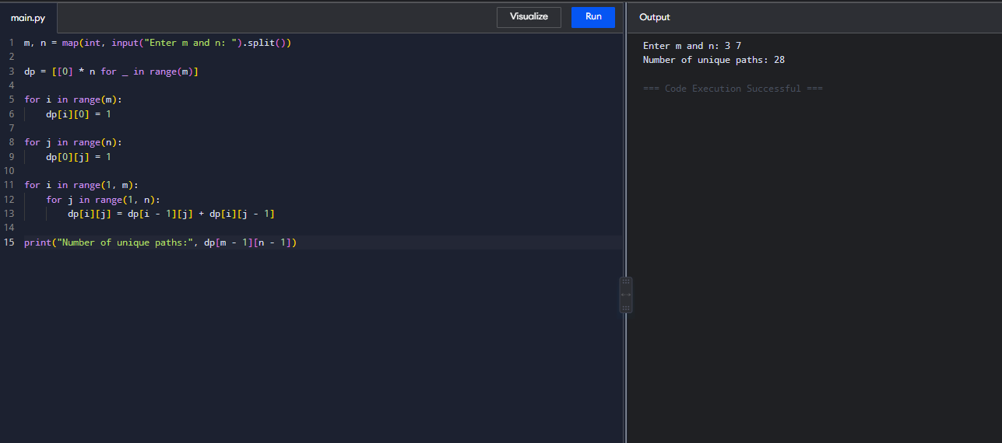
Time Complexity: O(m × n)
Space Complexity: O(m × n)

20,
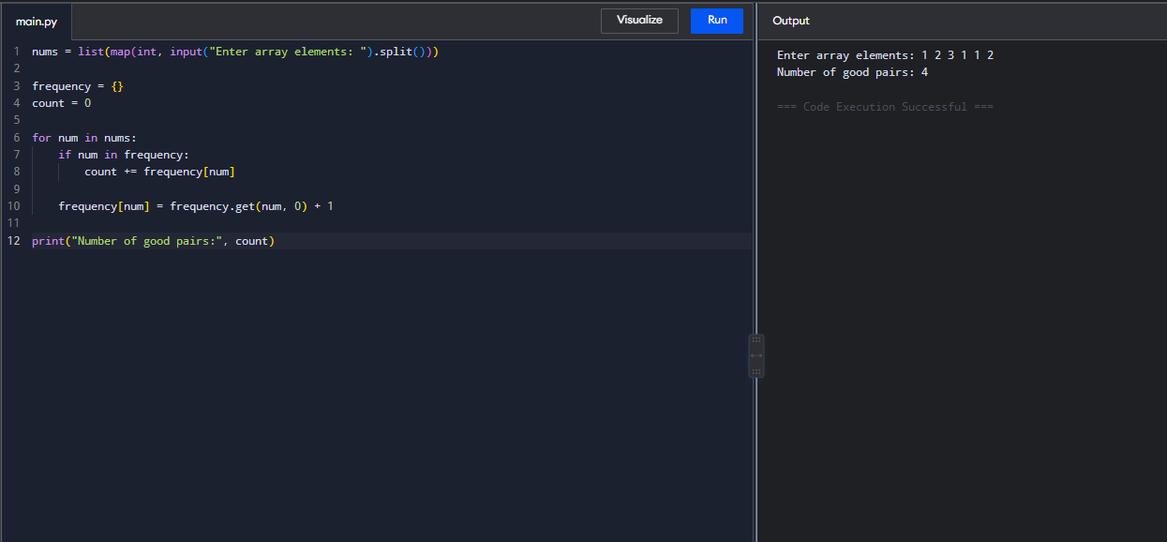
Time Complexity: O(n)
Space Complexity: O(n)

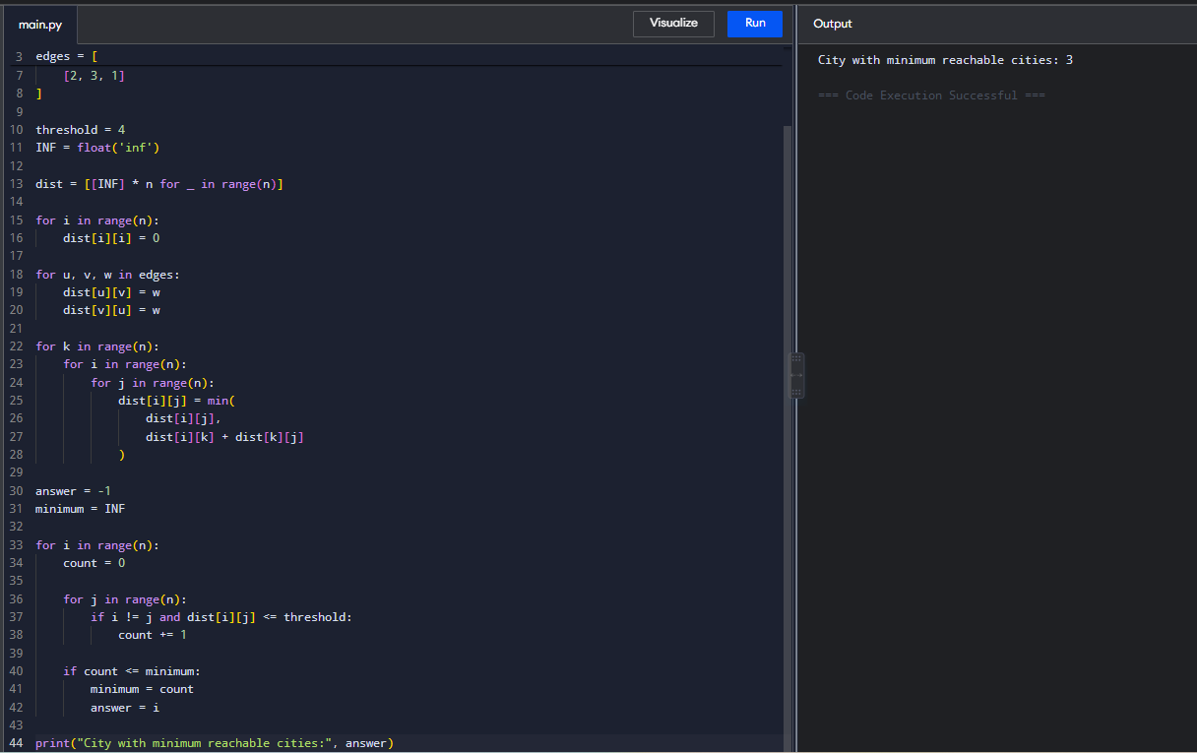
21,

Time Complexity: O(n³)
Space Complexity: O(n²)

22,
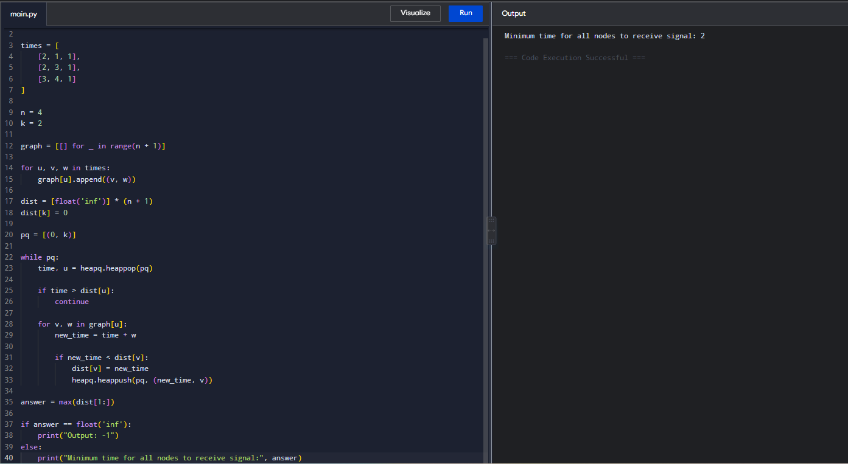
Time Complexity: O((V + E) log V)
Space Complexity: O(V + E)

